 | EUROPEAN COMMISSION  DIRECTORATE-GENERAL  TAXATION AND CUSTOMS UNION  Digital Delivery of Customs and Taxation Policies  Taxation Systems & Digital Governance

Payment Data XSD User Guide
CESOP
Date: | 08/11/2024
Status: | Submitted for acceptance (SfA)
Version: | 6.00
Author: | SOFT-DEV
Approved by: | DG TAXUD
Reference number: | DLV-599-10-89-1
Public: | DG TAXUD internal
Confidentiality: | Publicly available (PA)

Document control information

Property | Value
Title | Payment Data XSD User Guide
Subtitle | CESOP
Author | SOFT-DEV
Project owner | Head of Unit of DG TAXUD Unit C4 Tax administration and fight against tax fraud
Solution provider | DG TAXUD Unit B4 Taxation Systems & Digital Governance
DG TAXUD Project Manager | Ioan MARTINAS
Version | 6.00
Confidentiality | Publicly available (PA)
Date | 08/11/2024

Contract information

Property | Value
Framework Contract | TAXUD/2021/CC/162
Specific Contract | SC20-599

Document history
The document author is authorised to make the following types of changes to the document without requiring that the document be re-approved:
- Editorial, formatting, and spelling.
- Clarification.
To request a change to this document, contact the document author or project owner.
Changes to this document are summarised in the table in reverse chronological order (latest version first).

Version | Date | Description | Action | Section
6.00 | 08/11/2024 | Implementation of the review comments in the scope of SC20-599.  Version Submitted for Acceptance (SfA). | R | Document history, 2.2.1, 3.1.3.3, 3.3.1.3, 3.3.3.1, 3.4.20, 4, 4.2, 5
5.10 | 22/10/2024 | Implementation of the following RfCs in the scope of SC20-599:  - CESOP-1811: Enhance explanation for naming convention in XSD User Guide;  - CESOP-1913: Update RP-BR-0030 (error code 40030) to validate the IBAN length against the country code within the IBAN;  - CESOP-1945: Add a new BR RT-BR-0090 for the proper use of the CorrTransactionIdentifier;  - CESOP-1970: Further describe the case of correction, that should contain all transactions;  - CESOP-1997: Create a dedicated error code for the case of same payee reported under different ReportedPayee elements;  - CESOP-2113: Update the full description of MH-BR-0010;  - CESOP-2114: Update the full description of MH-BR-0120;  - CESOP-2115: Update the full description of CM-BR-0050;  - CESOP-2116: Update the full description of CM-BR-0060;  - CESOP-2117: Update the full description of RP-BR-0080;  - CESOP-2118: Add a footnote regarding the refunds next to the description of RT-BR-0050;  - CESOP-2119: Add a footnote next to the description of CM-TR-0080 to explain that the other errors list is provided;  - CESOP-2169: Update the correlation error description of error code 20070;  - CESOP-2232: New business rules for the use of several account identifiers;  - CESOP-2238: [Documentation] Update the description of CM-BR-0130 & CM-BR-0140;  - CESOP-2273: Set transmitting country based on TAPAS party ID in case of unreadable message;  - CESOP-2286: Stop support of XSD schema v4.00 and 4.01;  - CESOP-2287: New BR to ensure that the AccountIdentifier type “Other” is not set to IBAN / BIC / OBAN.  Version Submitted for Review (SfR). | I/R | 1.5, 2.2.1, 3.1.3.3, 3.3.1.3, 3.3.2.3, 3.3.3.1, 3.4.20, 4, 4.1, 4.2, 4.3, 5
5.00 | 05/04/2024 | Implementation of the review comments in the scope of SC15-566.  Version Submitted for Acceptance (SfA). | R | All
4.90 | 18/03/2024 | Implementation of the following RfCs in the scope of SC15-566  - CESOP-908: Correction of reported payees initially reported in different payment data messages - new BR;  - CESOP-916: Remove Business Rule PS-BR-0010 (error code 30010);  - CESOP-970: Modify BR RT-BR-0030 to have at least one date in reporting period and to take into account the settlement date;  - CESOP-985: Remove Business Rule MH-BR-0020 (error code 10020);  - CESOP-1103: Support all ISO-3166 for BICs;  - CESOP-1222: New BR to validate if transactions are included in the PMT message in case of deletion request;  - CESOP-1226: Add a new scenario for the case where all payees are partially rejected;  - CESOP-1336: Extend length of transactionidentifier;  - CESOP-1338: Add information regarding the implementation of error code 20010;  - CESOP-1360: Settlement date as new value in TransactionDateType_Type enumeration;  - CESOP-1480: Reporting of both BIC AND Account Number must be allowed by XSD;  - CESOP-1494: Override transaction IDs in case the refund ID the same;  - CESOP-1541: Add support for VOES identifiers in PMT messages;  - CESOP-1589: Remove error codes enumeration from the XSD;  - CESOP-1598: Documenting the supported XSD versions for CESOP releases;  - CESOP-1681: XSD - Add optional description element for “OTHER” in enumerations;  - CESOP-1694: CESOP PING message type;  - CESOP-1706: XSD – Currency Code Sierra Leone from SLL to SLE;  - CESOP-1724: Add BR to ensure proper use of optional description element for “OTHER” in enumerations.  Version Submitted for Review (SfR). | I/R | 1.7, 2.2.1, 2.2.2, 2.2.3.2, 2.2.3.6, 2.2.3.7, 2.2.3.9, 2.2.3.11, 2.2.3.13, 2.2.3.17, 2.2.3.18, 2.2.4.10, 2.2.4.11, 2.2.4.15, 2.2.4.17, 2.2.4.22, 2.2.4.23, 3.1.2, 3.1.4, 3.3.1.3, 3.3.2.3, 3.3.4, 3.4.6, 3.4.19, 4.1, 4.2, 4.3
4.80 | 12/02/2024 | Implementation of review comments and of the following RfC:  - CESOP-1782: CESOP non EU PSP BIC - Update the XSD User Guide to propose using the 'Other'.  Version Submitted for Acceptance in scope of RfA SC10-491. | R | 2.2.4.6, 3.3.2, 3.3.3.1, 3.4.5, 3.4.9
4.70 | 30/01/2024 | Implementation of the following RfCs in the scope of SC10-491:  - CESOP-1493: Adding clarifications for the correlation mechanism in the XSD User Guide;  - CESOP-1715: Handle “1” as “true” for xs:boolean fields.  Version Submitted for Review (SfR). | I/R | 2.2.3.7, 3.3.2, 3.3.3, 3.4
4.61 | 20/11/2023 | Update of the confidentiality level of the present document, to “Publicly Available (PA)”.  Version Submitted for Information (SfI). | R | Cover page, document control information, 1.7
4.60 | 08/08/2023 | Implementation of review comments.  Version Submitted for Acceptance in scope of RfA SC08-279. | R | 3.3.2.2, 3.3.3.1, 3.4.7, 3.4.17
4.50 | 01/08/2023 | Implementation of the following RfCs in the scope of SC08-279:  - CESOP-1032: [XSD User Guide] Correlation between two Payment Data messages;  - CESOP-1113: XSD - Update regex of TAXIdentification_Type to consider minus “-”;  - CESOP-1194: CESOP XSD User Guide - Clarification regarding message where all payees are erroneous.  Version Submitted for Review (SfR). | R | 2.2.4.12, 3.1.2, 3.3.2.2, 3.4.7, 3.4.17
4.40 | 14/06/2023 | Implementation of review comments.  Version Submitted for Acceptance in scope of RfA SC07-423. | R | 2.2.2, 2.2.3.2, 2.2.3.7, 2.2.4.24, 3.1.2, 3.3.2.2, 3.3.2.3, 4.4
4.30 | 02/06/2023 | Implementation of the following RfCs in the scope of SC07-423:  - CESOP-818: XSD - Update MH-BR-0090 to reject VLD messages (in both VM and CESOP app);  - CESOP-819: CESOP - TransactionIdentifier Uniqueness in the System;  - CESOP-821: XSD (User Guide) - Update of representative definitions;  - CESOP-863: XSD User Guide - Update footnote related to files compression;  - CESOP-864: XSD - Update regex of TAXIdentification_Type;  - CESOP-870: XSD User guide - Removal of DAC2 references;  - CESOP-878: XSD - Update of the Timestamp validation regex;  - CESOP-918: Clarification RP-BR-0040 in XSD user guide;  - CESOP-930: Remove obsolete business rule RT-BR-0020 (error code 45020);  - CESOP-967: Partial Rejection of a Spontaneous Correction Data Message.  Version Submitted for Review (SfR). | I/R | 1.7, 2.1, 2.2.3.5, 2.2.3.6, 2.2.3.7, 2.2.3.18, 2.2.4.12, 2.2.4.24, 3.3.1.1, 3.3.2.2, 3.4.17, 4.1, 4.3, 4.4
4.20 | 02/06/2023 | Implementation of review comments.  Version Submitted for Acceptance in scope of RfA SC08-279. | R | 1.7, 3.1.3.2.2, 3.1.3.2.3, 3.3.1.1, 3.3.3.1, 4.4
4.10 | 22/05/2023 | Implementation of the following RfCs in the scope of SC08-279:  - CESOP-567: Validate if transmitting country equals the partner id country;  - CESOP-568: Validate if transmitting country equals the country of the uploader;  - CESOP-811: Migration of CFSS into XSD User Guide;  - CESOP-903: XSD material update the comment for StringMin1Max40_Type.  Version Submitted for Review (SfR). | I/R | 1.5, 1.7, 2.2.3.18, 3, 3.2.1.1, 3.2.2.1, 3.2.2.2, 3.2.3, 3.3.1.1, 3.3.1.3, 3.3.3.1, 4.1
4.00 | 13/01/2022 | Version Submitted for Acceptance in scope of RfA SC08-047 | I/R | All sections have been revised.
3.10 | 20/12/2022 | Version Submitted for Review in scope of RfA SC08-047. | I/R | All sections have been revised.
3.00 | 03/02/2022 | Version Submitted for Acceptance in scope of RfA SC04-062. | I/R | 2.2.3.15 ValidationError_Type  - TransactionIdentifier added
2.01 | 24/01/2022 | Implementation of the Expert Team, Expert Group and ITSM3 TES comments. | I/R | All sections have been revised
2.00 | 03/12/2021 | Version Submitted for Acceptance in scope of RfA SC13-666.  Implement review comments. | I/R | All sections have been revised
1.02 | 17/11/2021 | Implementation of TAXUD and ET comments.  Version Submitted for Information (SfI). | I/R | All sections have been revised.
1.01 | 11/11/2021 | Implementation of the Member States’ comments.  Version Submitted for Review (SfR). | I/R | All sections have been revised.
1.00 | 27/08/2021 | Implementation of the review comments.  Version submitted for Acceptance (SfA). | I/R | All sections have been revised.
0.01 | 02/08/2021 | Initial version of the document in the scope of RfA SC13-666.  Version Submitted for Review (SfR). | I | All
Action: I=Insert R=Replace

Table of contents
1 Introduction 10
1.1 Document purpose 10
1.2 Target audience 10
1.3 Scope 11
1.4 Structure 11
1.5 Reference documents 11
1.6 Applicable documents 12
1.7 Abbreviations & acronyms 13
1.8 Definitions 14
2 Payment Data XML Schema Definition 17
2.1 Introduction 17
2.2 Definition of the CESOP Payment Data Message 17
2.2.1 Versioning 18
2.2.2 Structure of the Payment Data Message 19
2.2.3 Definition of the Payment Data XSD elements 30
2.2.4 Definition of the Common types XSD elements 44
3 Significant Use Cases 63
3.1 General overview 63
3.1.1 Quarterly submission of Payment Data 63
3.1.2 Payment Data message validation 64
3.1.3 Validation Result message 65
3.1.4 Ping message 68
3.2 Detailed Use Cases 68
3.2.1 Acceptance of Payment Data message 69
3.2.2 Rejection of the Payment Data message 71
3.2.3 Submission of several Payment Data messages by the PSP for the same reporting period 74
3.3 Additional Specifications 75
3.3.1 File characteristics 75
3.3.2 Correlation mechanism 78
3.3.3 Correction of messages 83
3.3.4 Refunds 85
3.4 Examples of message exchanges scenarios 86
3.4.1 Acceptance of the Payment Data message by CESOP 86
3.4.2 Full rejection of the Payment Data message by the National Tax Administration, and subsequent correction by the PSP 87
3.4.3 Full rejection of the Payment Data message by CESOP for technical errors for which the NTA is responsible of 88
3.4.4 Full rejection of the Payment Data message by CESOP, and subsequent correction by the PSP 89
3.4.5 Partial rejection of a Payment Data message and subsequent correction by the PSP 90
3.4.6 Partial rejection of a Payment Data message with all Payees breaching a business rule, and subsequent correction by the PSP 93
3.4.7 Complex case with full rejection at CESOP level, then full rejection at NTA level 95
3.4.8 Complex case with partial rejection at CESOP level, then full rejection at NTA level 97
3.4.9 Spontaneous correction of the PSP information 99
3.4.10 Spontaneous correction of an accepted Reported Payee 100
3.4.11 Deletion of an accepted Reported Payee 102
3.4.12 Correction/deletion of transactions related to an accepted Reported Payee 104
3.4.13 Submission of omitted data by the PSP 105
3.4.14 Submission of split Payment Data messages by the PSP 107
3.4.15 Submission of a “No Payment Data to report” message by the PSP 110
3.4.16 Double submission of a same Payment Data message 111
3.4.17 Too many errors in the received Payment Data message 113
3.4.18 Complex case with spontaneous correction of an accepted Reported Payee, partial rejection at CESOP level and subsequent correction by the PSP 113
3.4.19 Ping messages exchange 116
3.4.20 Full rejection of a Payment Data message containing multiple times the same reported Payee, and subsequent correction by the PSP 117
4 Business rules 119
4.1 Message header and Common business rules 119
4.2 Reported Payee business rules 123
4.3 Reported transaction business rules 129
5 Technical rules 131
6 Annex I: XSD Symbols 133
7 Annex II: UUID v4 134
7.1 Definition 134
7.2 Collision risk 134

List of tables
Table 1: Reference documents 12
Table 2: Applicable documents 12
Table 3: Abbreviations and acronyms 14
Table 4: Definitions 16
Table 5: Version mapping 18
Table 6: CESOP Common business rules 123
Table 7: CESOP Reported Payee rules 128
Table 8: CESOP Reported transaction rules 130
Table 9: CESOP technical rules 132
Table 10: XSD Symbols 133

List of figures
Figure 1: XML schema root definition: CESOP 19
Figure 2: XML schema definition: MessageSpec 20
Figure 3: XML schema definition: PaymentDataBody 21
Figure 4: XML schema definition: PSP 21
Figure 5: XML schema definition: ReportedPayee 22
Figure 6: XML schema definition: Representative 23
Figure 7: XML schema definition: Address 24
Figure 8: XML schema definition: AccountIdentifier 25
Figure 9: XML schema definition: ReportingPeriod 25
Figure 10: XML schema definition: TaxIdentifier 26
Figure 11: XML schema definition: ReportedTransaction 27
Figure 12: XML schema definition: DocSpec 28
Figure 13: XML schema definition: ValidationResult 29
Figure 14: Detailed Use Cases - Payment Data message 69
Figure 15: Detailed Use Cases - No Payment Data message 70
Figure 16: Detailed Use Cases – Rejection of Payment Data message by the National Tax Administration 71
Figure 17: Detailed Use Cases – Rejection of Payment Data message by CESOP 72
Figure 18: Detailed Use Cases - Submission of several Payment Data messages by the PSP for the same reporting period 74
Figure 19: Correlation of the messages – Examples – Validation Result message 78
Figure 20: Correlation of the messages – Examples – Correction message 79
Figure 21: Correlation of the Payees – Examples – Validation Result message 80
Figure 22: Correlation of the Payees – Examples – Correction message 81

Introduction

Document purpose
The aim of this document is to provide a User Guide for the XML Schema of the Payment Data to be submitted by the Payment Service Providers (PSPs) and then transmitted by the National Tax Administrations to the Central Electronic System of Payment Information (CESOP).
This User Guide explains the data required to be included in each element to be reported in the CESOP XML Schema.
The CESOP project supports the implementation of:
- The Council Regulation (EU) 2020/283 of 18 February 2020 amending Regulation (EU) No 904/2010 as regards measures to strengthen administrative cooperation to combat VAT fraud;
- The Council Directive (EU) 2020/284 of 18 February 2020 amending Directive 2006/112/EC as regards introducing certain requirements for payment service providers.
The XML Schema and User Guide are designed to technically support the Payment Data transfer from the PSPs to CESOP, going through the Member States. It is important to note that the Member States are not allowed to alter the data submitted by the PSPs, and therefore the XML files shall remain identical from the origin (PSPs) to the destination (CESOP). The XML schema is intended to facilitate the use of the Payment Data by both National Tax Administrations and CESOP as it ensures that the format of PSP submissions is standardised.

Target audience
The target audience for this document includes:
- DG TAXUD, in particular Units B4 as System Supplier and C4 as System Owner;
- The European Commission governance bodies;
- The applicable DG TAXUD contractors;
- The Fiscalis CESOP Operational Team (OT);
- The Fiscalis Project Group (FPG) 123 and 133;
- The Standing Committee on Administrative Cooperation (SCAC);
- The Standing Committee on Information Technology (SCIT);
- The Payment Service Providers (PSPs);
- The Member State TAX Administrations (MSs);
- The Quality Assurance (QA5).

Scope
The scope of the XSD User Guide is the definition of the Payment Data XML schema definition that follows:
- The approach of other distributed Trans-European Systems (TESs), inspired by the OECD standards;
- The Council Regulation (EU) 2020/283 [R01];
- The Council Directive (EU) 2020/284 [R02];
- The listing of significant use cases regarding the flows from the PSPs to CESOP, going through the National Tax Administrations, independently from the reported payment methods.

Structure
This document is organised as follows:
- Chapter 1 – Introduction: describes the scope and the objectives of the document;
- Chapter 2 – Payment Data XML Schema Definition: defines the structure of the Payment Data XSD and describes all the elements with legal base references;
- Chapter 3 – Significant Use Cases: the chapter lists and describes the important use cases, focusing on the communication between the PSP and National Tax Administration, and between the National Tax Administration and CESOP;
- Chapter 4 – Business rules: defines all the business rules to check the Payment Data message validity;
- Chapter 5 – Technical rules: defines all the technical rules to check the Payment Data message validity;
- Annex I: XSD Symbols: the annex provides the semantic of the XSD Symbols used through the document;
- Annex II: UUID v4: this annex describes further the usage of UUIDs for unique identifiers.

Reference documents
The table below lists the documents that are referred to in the current document.
Ref. | Title | Originator | Version/Link | Date
R01 | Council Regulation (EU) 2020/283 of 18 February 2020 amending Regulation (EU) No 904/2010 as regards measures to strengthen administrative cooperation in order to combat VAT fraud | EC | https://eur-lex.europa.eu/eli/reg/2020/283/oj | 18/02/2020
R02 | Council Directive (EU) 2020/284 of 18 February 2020 amending Directive 2006/112/EC as regards introducing certain requirements for payment Service providers | EC | https://eur-lex.europa.eu/eli/dir/2020/284/oj | 18/02/2020
R03 | Regulation (EU) 575/2013 of the European Parliament and of the Council of 26 June 2013 on prudential requirements for credit institutions and investment firms and amending Regulation (EU) No 648/2012 | EC | https://eur-lex.europa.eu/legal-content/EN/TXT/HTML/?uri=CELEX:32013R0575&from=fr | 26/06/2013
R04 | Directive (EU) 2015/2366 of the European Parliament and of the Council of 25 November 2015 on payment services in the internal market, amending Directives 2002/65/EC, 2009/110/EC and 2013/36/EU and Regulation (EU) No 1093/2010, and repealing Directive 2007/64/EC | EC | https://eur-lex.europa.eu/legal-content/EN/TXT/HTML/?uri=CELEX:32015L2366&from=FR | 25/11/2015
R05 | Commission Implementing Regulation (EU) 2022/1504 of 6 April 2022 laying down detailed rules for the application of Council Regulation (EU) No 904/2010 as regards the creation of a central electronic system of payment information (CESOP) to combat VAT fraud | EC | https://eur-lex.europa.eu/eli/reg_impl/2022/1504/ | 06/04/2022
R06 | CESOP – Architecture Overview | SOFT-DEV | 7.00 | 25/04/2024
R07 | CESOP Validation Module – User Manual | SOFT-DEV | 5.00 | N/A
Table 1: Reference documents

Applicable documents
The table below lists the documents to which the current document must be compliant (e.g., SC, RfA).
Ref. | Title | Reference | Version | Date
A01 | Framework Contract | TAXUD/2021/CC/162 | N/A | 24/06/2021
A02 | Specific Contract n°20 | TAXUD/ 2024/DE/122 | N/A | 23/04/2024
Table 2: Applicable documents

Abbreviations & acronyms
For a better understanding of the present document, the following table provides a list of the principal abbreviations and acronyms used.
See also the ‘list of acronyms’ on TEMPO.
Abbreviation/Acronym | Definition
B2C | Business to Customer
BIC | Bank Identifier Code
CESOP | Central Electronic System of Payment Information
CRS | Common Reporting Standard
DG TAXUD | Directorate-General Taxation and Customs Union
EC | European Commission
EU | European Union
FPG | Fiscalis2020 Project Group
G20 | Group of twenty
IBAN | International Bank Account Number
IOSS | Import One Stop Shop
ISO | International Organization for Standardization
IT | Information Technology
MS | Member State
NA | National Administration
NTA | National Tax Administration
OBAN | Other Bank Account Number
OECD | Organisation for Economic Co-operation and Development
PA | Publicly Available
PSP | Payment Service Provider
SC | Steering committee
SCAC | Standing Committee on Administrative Cooperation
SCIT | Standing Committee on Information Technology
TEMPO | TAXUD Electronic Management of Projects Online
TES | Trans-European System
TIN | Tax Identification Number

Abbreviation/Acronym | Definition
UTC | Coordinated Universal Time
UTF-8 | Universal Character Set – 8 bits
UUID | Universally Unique Identifier
VOES | VAT on e-Services
W3C | World Wide Web Consortium
XML | Extensible Mark-up Language
XSD | XML Schema Definition
Table 3: Abbreviations and acronyms

Definitions
For a better understanding of the present document, the following table provides a list of the principal terms used.
See also the ‘glossary’ on TEMPO.
Abbreviation/Acronym | Definition
XSD (XML Schema Definition) | XSD (XML Schema Definition) is a World Wide Web Consortium (W3C) recommendation that specifies how to formally describe the elements in an Extensible Markup Language (XML) document. This description can be used to verify that each item of content in a document adheres to the description of the element in which the content is to be placed.
Home Member State | Home Member State means either of the following:  - the Member State in which the registered office of the payment service provider is situated; or  - if the payment service provider has, under its national law, no registered office, the Member State in which its head office is situated.
Host Member State | Host Member State means the Member State other than the Home Member State in which a payment service provider has an agent or a branch or provides payment services.
Payee | Payee means a natural or legal entity who is the intended recipient of funds which have been the subject of a payment transaction.  The location of the payee shall be in the Member State, third territory or third country corresponding to:  - the IBAN of the payee’s payment account or any other identifier which unambiguously identifies, and gives the location of, the payee, or in the absence of such identifiers.  - the BIC or any other business identifier code that unambiguously identifies, and gives the location of, the payment service provider acting on behalf of the payee.
Payer | Payer means a natural or legal entity who holds a payment account and allows a payment order from that payment account, or, where there is no payment account, a natural or legal person who gives a payment order.
Payment Service Provider | Payment Service Provider means:  - credit institutions as defined in point (1) of Article 4(1) of Regulation (EU) No 575/2013 [R03] of the European Parliament and of the Council (28), including branches thereof within the meaning of point (17) Article 4(1) of that Regulation where such branches are located in the Union, whether the head offices of those branches are located within the Union or, in accordance with Article 47 of Directive 2013/36/EU and with national law, outside the Union;  - electronic money institutions within the meaning of point (1) of Article 2 of Directive 2009/110/EC, including, in accordance with Article 8 of that Directive and with national law, branches thereof, where such branches are located within the Union and their head offices are located outside the Union, in as far as the payment services provided by those branches are linked to the issuance of electronic money.  - post office giro institutions which are entitled under national law to provide payment services.  - payment institutions.
Payment Service | “Payment service” means any of the business activities set out in points (3) to (6) of Annex I to Directive (EU) 2015/2366 [R04]. These are:  “1. Execution of payment transactions, including transfers of funds on a payment account with the user’s payment service provider or with another payment service provider:  (a) execution of direct debits, including one-off direct debits.  (b) execution of payment transactions through a payment card or a similar device.  (c) execution of credit transfers, including standing orders.  2. Execution of payment transactions where the funds are covered by a credit line for a payment service user:  (a) execution of direct debits, including one-off direct debits.  (b) execution of payment transactions through a payment card or a similar device.  (c) execution of credit transfers, including standing orders.  3. Issuing of payment instruments and/or acquiring of payment transactions.  4. Money remittance.”
Residence | The country of residence is the country, where the Payment Service Provider is registered for tax duties.
Submit/submission | The expression submit/submission is used for data exchange between the PSPs and National Tax Administrations. As this exchange relates to external/national domain, this document does not define the means of this information exchange.
Transmit/transmission | The expression transmit/transmission is used for data exchange between the National Tax Administrations and the CESOP system. This transmission may imply different means of transport, like physical upload of file to CESOP system or system-to-system exchange of data.
Table 4: Definitions

Payment Data XML Schema Definition

Introduction
The Payment Data XSD defined below follows the Council Regulation (EU) 2020/283 [R01] and Council Directive (EU) 2020/284 [R02]. The legal reference is provided for the mandatory and some optional elements:
- The Payment Data XSD has been constructed with the help of the CESOP Expert Team (CESOP Expert Team focuses on implementing the IT aspect of the legislative package and the development of CESOP system);
- The Payment Data XSD enables the exchanges of additional attributes, which are not mandatory since not legally enforced, but that might help in the context of the B2C VAT Fraud risk analysis related activities.
The Payment Data XSD follows the approach of other TES related projects and will be used for exchange of Payment Data between the following stakeholders:
- The Payment Service Providers and the National Tax Administrations;
- And subsequently between the National Tax Administrations and CESOP.
The Payment Data XSD follows and re-uses as much as possible the building blocks already used in other taxation systems and projects and is deeply based on the OECD CRS. The CRS has been developed by the OECD in response to a request of the G20 and is used at a worldwide scale by financial institutions and tax jurisdictions for the reporting and exchanging financial data.
It is worth to note that all the messages exchanged within the subject of this document take the form of XML.

Definition of the CESOP Payment Data Message
The Payment Data message follows the XML schema definition defined by the following files, all provided in the Linked Resources of the present document:
- The ‘PaymentData.xsd’ file, including the main elements included in the Payment Data message, all further described in section 2.2.3;
- The ‘commontypes.xsd’ file, including all the types of common interests such as VAT identification numbers, TAX identification numbers, etc. These elements are further described in section 2.2.4;
- The ‘isotypes.xsd’ file, including all the ISO Codes regarding the countries, the Member States, and the currencies. For readability purposes, the documentation of this XSD is not generated and available through the present document.

Versioning
The aim of the versioning mechanism is to ensure a smooth transition from one version of the XML schema to the next. The following versioning mechanism applies to the XML schema:
- The root element of the XML schema has its version attribute set to the actual version number of the schema, including its major and minor version numbers. The minor number is incremented whenever a change is made to the schema that is compatible with existing XML documents built with the previous schema version;
- The major version number is modified only when a schema modification is incompatible with XML documents built according to the rules of the previous schema version. As each namespace name includes the major version number of the elements it defines, existing XML instance documents must be validated against the XML schema used to build these documents while new documents must be validated against the new release of the schema;
- For example, the first release of the XML schema has the main CESOP namespace “urn:ec.europa.eu:taxud:fiscalis:cesop:v1” and version 1.00 – the final two characters of the namespace (“v1”) correspond to the major version number (1).
On CESOP side, the central system and the validation module may support several minor versions of the XSD. The implementation works as follows:
- If a file is transmitted to CESOP with a supported version, the system will always validate this file according to that version and based on the mapping provided in the CESOP Validation Module User Manual [R07] (thus, if a file from v4.02 is uploaded, the validation result will be generated based on the v4.02 of the XSD);
- If a file is transmitted to CESOP where the version of the XSD is not specified or is specified but not supported, the file will be considered as invalid and will thus be fully rejected.
Note: XSD versions v4.00 and v4.01 are not supported anymore since CESOP release version v1.7.0.

The following table shows how the XML schema versions are correlated with the XSD User Guide(s) and the CESOP release version(s):
XML schema version | XSD User Guide version | CESOP release version | Supported XSD versions
4.03 | 6.00 | 1.7.0 | 4.02, 4.03
4.03 | 5.00 | 1.6.0 | 4.00, 4.01, 4.02, 4.03
4.02 | 4.80 | 1.5.0 | 4.00, 4.01, 4.02
4.02 | 4.61 | 1.3.0, 1.4.0 | 4.00, 4.01, 4.02
4.02 | 4.60 | 1.3.0, 1.4.0 | 4.00, 4.01, 4.02
4.02 | 4.40 | 1.3.0, 1.4.0 | 4.00, 4.01, 4.02
4.01 | 4.20 | 1.3.0, 1.4.0 | 4.00, 4.01, 4.02
4.00 | 4.00 | 1.2.0 | 4.00
Table 5: Version mapping
Note that:
- The above mapping only considers the final document versions delivered in the scope of a release (i.e. intermediate versions, including versions sent for review, are not listed);
- It might happen that a CESOP release does not foresee a change in the XML schema nor in the XSD User Guide. In this latter scenario, the XSD and XSD user guide versions mapped with the previous CESOP release version listed are to be considered;
- Intermediate releases support the same XSD version(s) as the related major one (e.g. CESOP v1.5.1 supported the same XSD versions as CESOP 1.5.0).

Structure of the Payment Data Message
The overall structure of the message follows the design used in other distributed Trans-European Systems (TESs) financed by DG TAXUD and inspired by the OECD standards. The following picture depicts the overall structure of the CESOP Payment Data message.
Note: a description of the symbols used in the following schemas is provided in Annex I: XSD Symbols.

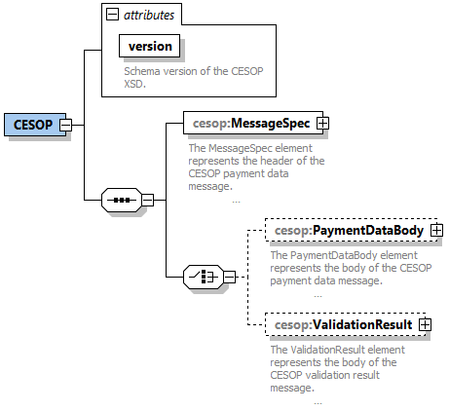
Figure 1: XML schema root definition: CESOP

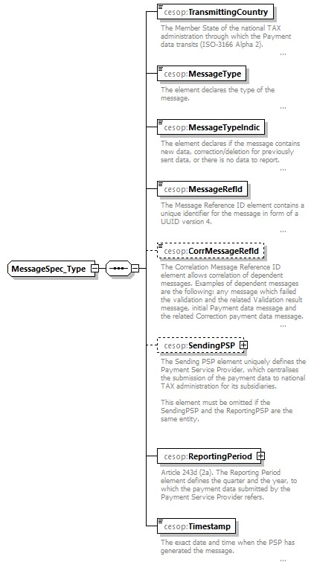
Figure 2: XML schema definition: MessageSpec

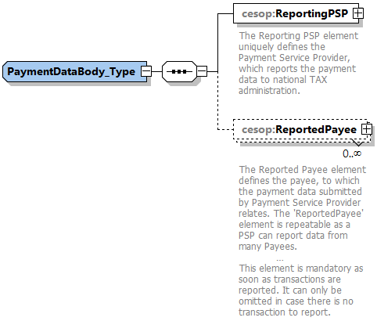
Figure 3: XML schema definition: PaymentDataBody

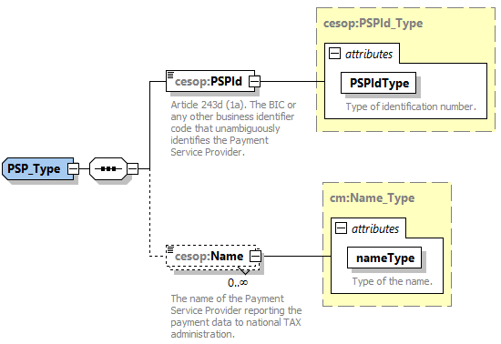
Figure 4: XML schema definition: PSP
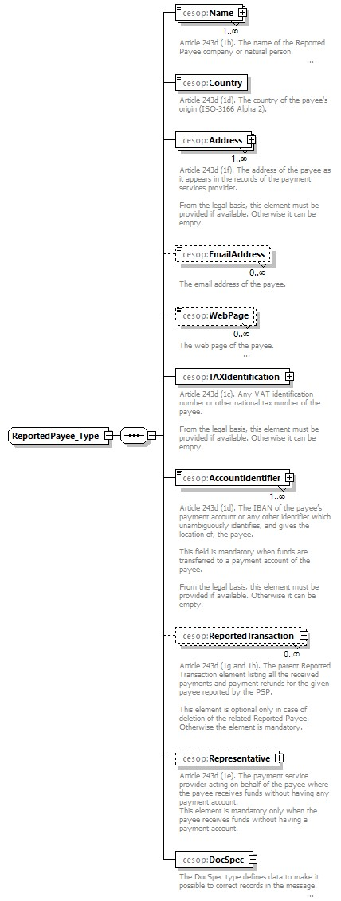
Figure 5: XML schema definition: ReportedPayee

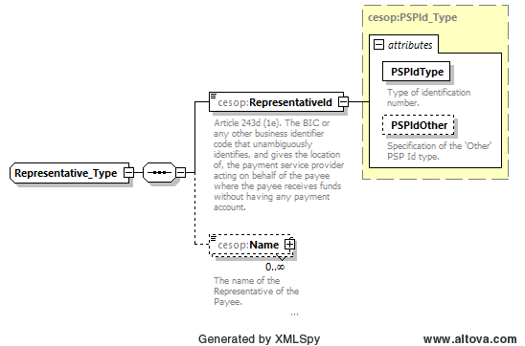
Figure 6: XML schema definition: Representative

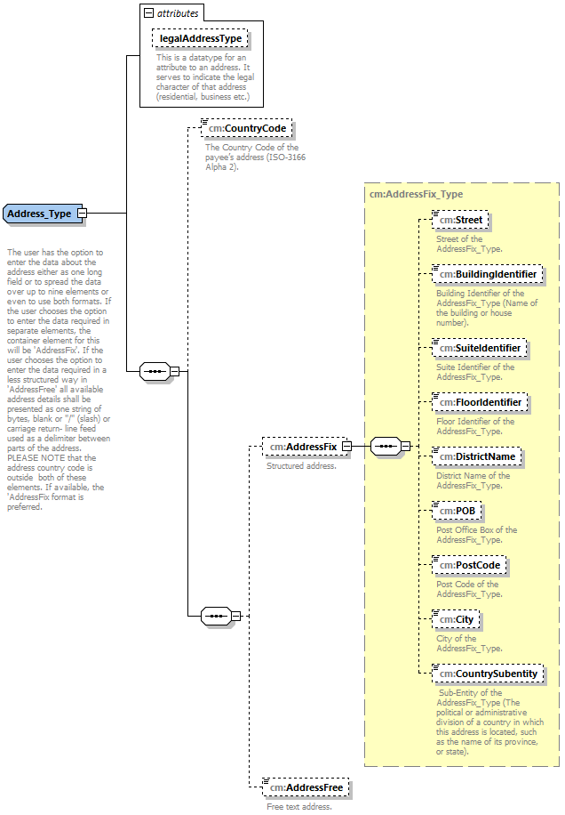
Figure 7: XML schema definition: Address

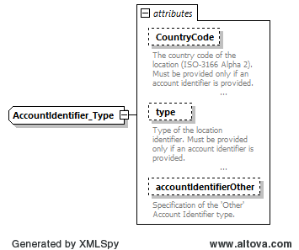
Figure 8: XML schema definition: AccountIdentifier

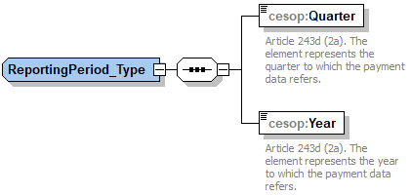
Figure 9: XML schema definition: ReportingPeriod

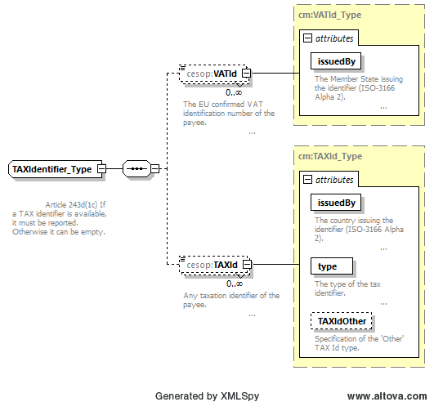
Figure 10: XML schema definition: TaxIdentifier
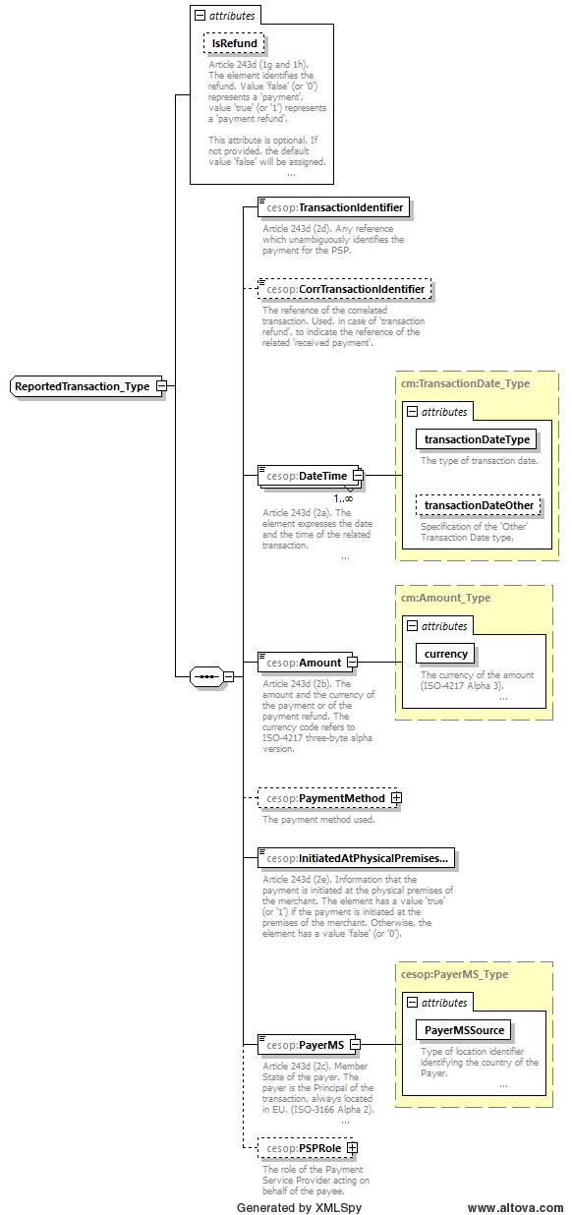
Figure 11: XML schema definition: ReportedTransaction

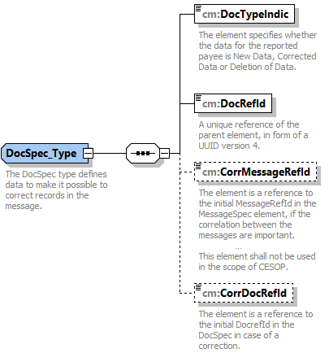
Figure 12: XML schema definition: DocSpec

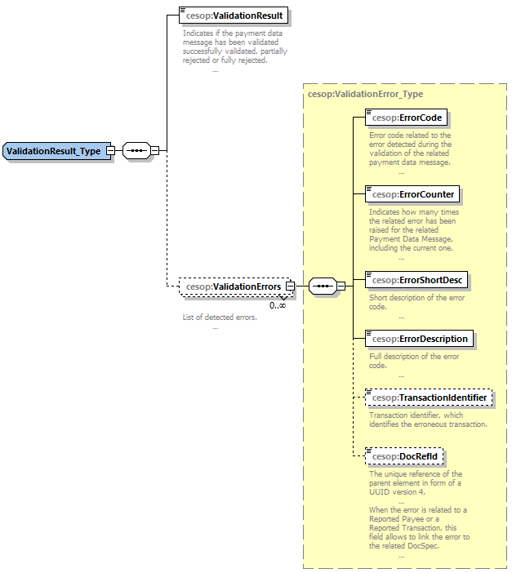
Figure 13: XML schema definition: ValidationResult

Definition of the Payment Data XSD elements
The tables below use the following semantics:
- Name: Name of the XML element.
- Description: Meaning of the XML element.
- Type: Type of the XML element.
- Mandatory Nature:
- Mandatory = Required by Law or technically mandated. The element must be provided and not empty.
- Optional mandatory = Required by Law if available. The element is technically mandatory but can be empty if not available.
- Optional = The element can be omitted.
- Cardinality: here lists the different possibilities like:
- 1 .. 1 = One and only One XML element (mandatory);
- 0 .. 1 = Zero or One XML element (optional);
- 1 .. unbounded = Multiple XML elements but at least One (mandatory);
- 0 .. unbounded = Multiple XML elements but can be also Zero (optional).

CESOP Payment Data message
CESOP Payment Data message root element.
Name | Description | Type | Mandatory Nature | Cardinality
MessageSpec | The MessageSpec element represents the header of the CESOP Payment Data message. | cesop:MessageSpec_Type | Mandatory | 1 .. 1
PaymentDataBody | The PaymentDataBody element represents the body of the CESOP Payment Data message. | cesop:PaymentDataBody_Type | Optional | 0 .. 1
ValidationResult | The ValidationResult element represents the body of the CESOP Validation Result message. | cesop:ValidationResult_Type | Optional | 0 .. 1
version (Attribute) | Schema version of the CESOP XSD. | xs:decimal | Mandatory | 1 .. 1

MessageSpec_Type
Name | Description | Type | Mandatory Nature | Cardinality
TransmittingCountry | The Member State of the National Tax Administration through which the Payment Data transits (ISO-3166 Alpha 2). | iso:MSCountryCode_Type | Mandatory | 1 .. 1
MessageType | The element declares the type of the message. | cesop:MessageType_Type | Mandatory | 1 .. 1
MessageTypeIndic | The element declares if the message contains new data, correction/deletion for previously sent data, or there is no data to report. | cesop:MessageTypeIndic_Type | Mandatory | 1 .. 1
MessageRefId | The Message Reference ID element contains a unique identifier for the message in form of a UUID version 4. | cm:UUID | Mandatory | 1 .. 1
CorrMessageRefId | The Correlation Message Reference ID element allows correlation of dependent messages. Examples of dependent messages are the following: any message which failed the validation and the related Validation Result message, initial Payment Data message and the related Correction Payment Data message. | cm:UUID | Optional | 0 .. 1
SendingPSP | The Sending PSP element uniquely defines the Payment Service Provider, which centralises the submission of the Payment Data to National Tax Administration for its subsidiaries.  This element must be omitted if the SendingPSP and the ReportingPSP are the same entity. | cesop:PSP_Type | Optional | 0 .. 1
ReportingPeriod | Article 243d (2a). The Reporting Period element defines the quarter and the year, to which the Payment Data submitted by the Payment Service Provider refers. | cesop:ReportingPeriod_Type | Mandatory | 1 .. 1
Timestamp | The exact date and time when the PSP has generated the message. | cm:dateTimeWithRequiredTimeZone | Mandatory | 1 .. 1

PaymentDataBody_Type
Name | Description | Type | Mandatory Nature | Cardinality
ReportingPSP | The Reporting PSP element uniquely defines the Payment Service Provider, which reports the Payment Data to National Tax Administration. | cesop:PSP_Type | Mandatory | 1 .. 1
ReportedPayee | The Reported Payee element defines the payee, to which the Payment Data submitted by Payment Service Provider relates. The ‘ReportedPayee’ element is repeatable as a PSP can report data from many Payees.  This element is mandatory as soon as transactions are reported. It can only be omitted in case there is no transaction to report. | cesop:ReportedPayee_Type | Optional | 0 .. unbounded

PSP_Type
Name | Description | Type | Mandatory Nature | Cardinality
PSPId | Article 243d (1a). The BIC or any other business identifier code that unambiguously identifies the Payment Service Provider. | cesop:PSPId_Type | Mandatory | 1 .. 1
Name | The name of the Payment Service Provider reporting the Payment Data to National Tax Administration. | cm:Name_Type | Optional | 0 .. unbounded

Representative_Type
Name | Description | Type | Mandatory Nature | Cardinality
RepresentativeId | Article 243d (1e). The BIC or any other business identifier code that unambiguously identifies, and gives the location of, the payment service provider acting on behalf of the payee where the payee receives funds without having any payment account. | cesop:PSPId_Type | Mandatory | 1 .. 1
Name | The name of the Representative of the Payee. | cm:Name_Type | Optional | 0 .. unbounded

ReportedPayee_Type
Name | Description | Type | Mandatory Nature | Cardinality
Name | Article 243d (1b). The name of the Reported Payee company or natural person. | cm:Name_Type | Mandatory | 1 .. unbounded
Country | Article 243d (1d). The country of the payee's origin (ISO-3166 Alpha 2). | iso:CountryCode_Type | Mandatory | 1 .. 1
Address | Article 243d (1f). The address of the payee as it appears in the records of the payment services provider.  From the legal basis, this element must be provided if available. Otherwise, it can be empty. | cm:Address_Type | Optional mandatory | 1 .. unbounded
EmailAddress | The email address of the payee. | cm:Email_Type | Optional | 0 .. unbounded
WebPage | The web page of the payee. | cm:WebPage_Type | Optional | 0 .. unbounded
TAXIdentification | Article 243d (1c). Any VAT identification number or other national tax number of the payee.  From the legal basis, this element must be provided if available. Otherwise, it can be empty. | cesop:TAXIdentifier_Type | Optional mandatory | 1 .. 1
AccountIdentifier | Article 243d (1d). The IBAN of the payee’s payment account or any other identifier which unambiguously identifies, and gives the location of, the payee.  This field is mandatory when funds are transferred to a payment account of the payee.  From the legal basis, this element must be provided if available. Otherwise, it can be empty. | cesop:AccountIdentifier_Type | Optional mandatory | 1 .. unbounded
ReportedTransaction | Article 243d (1g and 1h). The parent Reported Transaction element listing all the received payments and payment refunds for the given payee reported by the PSP.  This element is optional only in case of deletion of the related Reported Payee. Otherwise, the element is mandatory. | cesop:ReportedTransaction_Type | Optional | 0 .. unbounded
Representative | Article 243d (1e). The payment service provider acting on behalf of the payee where the payee receives funds without having any payment account.  This element is mandatory only when the payee receives funds without having a payment account. | cesop:Representative_Type | Optional mandatory | 0 .. 1
DocSpec | The DocSpec type defines data to make it possible to correct records in the message. | cm:DocSpec_Type | Mandatory | 1 .. 1

ReportedTransaction_Type
Name | Description | Type | Mandatory Nature | Cardinality
TransactionIdentifier | Article 243d (2d). Any reference which unambiguously identifies the payment for the PSP. | cm:StringMin1Max100_Type | Mandatory | 1 .. 1
CorrTransactionIdentifier | The reference of the correlated transaction. Used, in case of 'transaction refund', to indicate the reference of the related 'received payment'. | cm:StringMin1Max100_Type | Optional | 0 .. 1
DateTime | Article 243d (2a). The element expresses the date and the time of the related transaction. | cm:TransactionDate_Type | Mandatory | 1.. unbounded
Amount | Article 243d (2b). The amount and the currency of the payment or of the payment refund. The currency code refers to ISO-4217 three-byte alpha version. | cm:Amount_Type | Mandatory | 1 .. 1
PaymentMethod | The payment method Used. | cm:PaymentMethod_Type | Optional | 0 .. 1
InitiatedAtPhysicalPremisesOfMerchant | Article 243d (2e). Information that the payment is initiated at the physical premises of the merchant. The element has a value 'true' (or ‘1’) if the payment is initiated at the premises of the merchant. Otherwise, the element has a value 'false' (or ‘0’). | xs:boolean | Mandatory | 1 .. 1
PayerMS | Article 243d (2c). Member State of the payer. The payer is the Principal of the transaction, always located in EU. (ISO-3166 Alpha 2). | cesop:PayerMS_Type | Mandatory | 1 .. 1
PSPRole | The role of the Payment Service Provider acting on behalf of the payee. | cm:PSPRole_Type | Optional | 0 .. 1
IsRefund (Attribute) | Article 243d (1g and 1h). The element identifies the refund. Value 'false' (or ‘0’) represents a 'payment', value 'true' (or ‘1’) represents a 'payment refund'.  This attribute is optional. If not provided, the default value 'false' will be assigned. | cm:Refund_Type | Optional | 0 .. 1

ReportingPeriod_Type
Name | Description | Type | Mandatory Nature | Cardinality
Quarter | Article 243d (2a). The element represents the quarter to which the Payment Data refers. | cm:Quarter_Type | Mandatory | 1 .. 1
Year | Article 243d (2a). The element represents the year to which the Payment Data refers. | cm:Year_Type | Mandatory | 1 .. 1

PSPId_Type
Article 243d (1a and 1e). The BIC or any other business identifier code that unambiguously identifies the Payment Service Provider. As the identifier may be not strictly numeric, it is just defined as a string of characters. Attribute 'PSPIdType' defines the type of identification number.
PSPId_Type is an extension of cm:StringMin1Max200_Type.
Name | Description | Type | Mandatory Nature | Cardinality
PSPIdType (Attribute) | Type of identification number. | cm:PSPIdType_Type | Mandatory | 1 .. 1
PSPIdOther (Attribute) | Specification of the 'Other' PSP Id type. | cm:StringMin1Max200_Type | Optional | 0 .. 1

PayerMS_Type
PayerMS_Type is an extension of iso:MSCountryCode_Type.
Name | Description | Type | Mandatory Nature | Cardinality
PayerMSSource (Attribute) | Type of location identifier identifying the country of the Payer. | cm:AccountIdentifierType_Type | Mandatory | 1 .. 1

AccountIdentifier_Type
AccountIdentifier_Type is an extension of cm:StringMin0Max200_Type.
Name | Description | Type | Mandatory Nature | Cardinality
CountryCode (Attribute) | The country code of the location (ISO-3166 Alpha 2). Must be provided only if an account identifier is provided. | iso:CountryCode_Type | Optional | 0 .. 1
type (Attribute) | Type of the location identifier. Must be provided only if an account identifier is provided. | cm:AccountIdentifierType_Type | Optional | 0 .. 1
accountIdentifierOther (Attribute) | Specification of the 'Other' Account Identifier type. | cm:StringMin1Max200_Type | Optional | 0 .. 1

TAXIdentifier_Type
Article 243d(1c) If a TAX identifier is available, it must be reported. Otherwise, it can be empty.
Name | Description | Type | Mandatory Nature | Cardinality
VATId | The EU confirmed VAT identification number of the payee. | cm:VATId_Type | Optional | 0 .. unbounded
TAXId | Any taxation identifier of the payee. | cm:TAXId_Type | Optional | 0 .. unbounded

MessageType_Type
Description:
Restriction: xs:string
Enumeration:
- PMT: The message type is 'Payment data' (or 'No Payment data').
- VLD: The message type is 'Validation Result message';
- PNG: The message type is ‘Ping message'.

MessageTypeIndic_Type
Description:
Restriction: xs:string
Enumeration:
- CESOP100: The message contains new data.
- CESOP101: The message contains corrections or deletions of previously sent data.
- CESOP102: The message indicates there is no data to report.

ValidationResult_Type
Name | Description | Type | Mandatory Nature | Cardinality
ValidationResult | Indicates if the Payment Data message has been successfully validated, partially rejected or fully rejected. | cesop: ValidationResultType_Type | Mandatory | 1 .. 1
ValidationErrors | List of detected errors. | cesop:ValidationError_Type | Optional | 0 .. unbounded

ValidationResultType_Type
Description:
Restriction: xs:string
Enumeration:
- VALIDATED: The message has been positively validated.
- PARTIALLY REJECTED: The message has been partially rejected.
- FULLY REJECTED: The message has been fully rejected.

More details about the validation outcome are provided in section 3.1.2

ValidationError_Type
Name | Description | Type | Mandatory Nature | Cardinality
ErrorCode | Error code related to the error detected during the validation of the related Payment Data message. | cesop:ErrorCode_Type | Mandatory | 1 .. 1
ErrorCounter | Indicates how many times the related error has been raised for the related Payment Data Message, including the current one. | xs:integer | Mandatory | 1 .. 1
ErrorShortDesc | Short description of the error code. | cm:StringMin1Max100_Type | Mandatory | 1 .. 1
ErrorDescription | Full description of the error code. | cm:StringMin1Max1000_Type | Mandatory | 1 .. 1
TransactionIdentifier | Transaction identifier, which identifies the erroneous transaction. | cm:StringMin1Max100_Type | Optional | 0 .. 1
DocRefId | The unique reference of the parent element in form of a UUID version 4.  When the error is related to a Reported Payee or a Reported Transaction, this field allows to link the error to the related Docspec. | cm:UUID | Optional | 0 .. 1

ErrorCode_Type
Description:
Restriction: xs:string

Definition of the Common types XSD elements

Refund_Type
Description: The element indicates if the transaction is a payment or a payment refund.
Restriction: xs:Boolean

Year_Type
Description: The element represents the year to which the Payment Data refers.
Restriction: xs:string
Pattern: [0-9]{4}

Quarter_Type
Description: The element represents the quarter to which the Payment Data refers. The possible values are 1 for the first quarter, 2 for the second quarter, 3 for the third quarter and 4 for the fourth quarter.
Restriction: xs:integer
Min. Inclusive: 1
Max. Inclusive: 4

UUID
Description: UUID version 4.
Restriction: xs:string
Pattern: ([0-9A-Fa-f]{8}-[0-9A-Fa-f]{4}-4[0-9A-Fa-f]{3}-[89ABab][0-9A-Fa-f]{3}-[0-9A-Fa-f]{12})

PSPRole_Type
The role of the Payment Service Provider acting on behalf of the payee.
Name | Description | Type | Mandatory Nature | Cardinality
PSPRoleType | Type of PSP. | cm:PSPRoleType_Type | Mandatory | 1 .. 1
PSPRoleOther | Specification of the ’Other' type of PSP. | cm:StringMin1Max200_Type | Optional | 0 .. 1

PSPIdType_Type
Description: The element represents the type of the Payment Service Provider identifier.
Restriction: xs:string
Enumeration:
- BIC: The PSP Identifier is a BIC code.
- Other: Other PSP Identifier type.

PSPRoleType_Type
Description: The element represents the type of the Payment Service Provider.
Restriction: xs:string
Enumeration:
- Three party card scheme: The market category of the Payment Service Provider is Three party card scheme.
- Four party card scheme: The market category of the Payment Service Provider is Four party card scheme.
- E-money provider: The market category of the Payment Service Provider is E-money provider.
- Acquirer: The market category of the Payment Service Provider is Acquirer.
- e-Wallet provider: The market category of the Payment Service Provider is e-Wallet provider.
- Money Transfer operator: The market category of the Payment Service Provider is Money Transfer operator.
- Issuer of payment instruments: The market category of the Payment Service Provider is Issuer of payment instruments.
- Payment Processor: The market category of the Payment Service Provider is Payment Processor.
- E-payment: The market category of the Payment Service Provider is E-payment.
- Payment collector: The market category of the Payment Service Provider is Payment collector.
- Other: Other category of Payment Service Provider.

VATId_Type
VATId_Type is an extension of cm:VATIdentification_Type.
Name | Description | Type | Mandatory Nature | Cardinality
issuedBy (Attribute) | The Member State issuing the identifier (ISO-3166 Alpha 2). | iso:MSCountryCode_Type | Mandatory | 1 .. 1

VATIdentification_Type
Description: The confirmed VAT identification number of the payee.
Restriction: xs:string
Pattern: [A-Za-z0-9]{0,20}
Length: 20

TAXId_Type
TAXId_Type is an extension of cm:TAXIdentification_Type.
Name | Description | Type | Mandatory Nature | Cardinality
issuedBy (Attribute) | The country issuing the identifier (ISO-3166 Alpha 2). | iso:CountryCode_Type | Mandatory | 1 .. 1
type (Attribute) | The type of the tax identifier. | cm:TAXIdType_Type | Mandatory | 1 .. 1
TAXIdOther (Attribute) | Specification of the 'Other' TAX Id type. | cm:StringMin1Max200_Type | Optional | 0 .. 1

TAXIdType_Type
Description: Type of the national tax number of the payee.
Restriction: xs:string
Enumeration:
- UNCONFIRMED_VAT: Unconfirmed or National VAT identifier.
- TIN: Tax Identification Number (TIN).
- IOSS: Import One Stop Shop (IOSS-Id).
- VOES: Non-union scheme/VOES identifier.
- OTHER: Other tax identifier.

TAXIdentification_Type
Description: Any national tax number of the payee.
Restriction: xs:string
Pattern: [A-Za-z0-9\-+]{0,20}
Length: 20

Amount_Type
Amount_Type is an extension of cm:AmountCurrency_Type.
Name | Description | Type | Mandatory Nature | Cardinality
currency (Attribute) | The currency of the amount (ISO-4217 Alpha 3). | iso:currCode_Type | Mandatory | 1 .. 1

AmountCurrency_Type
Description: Article 243d (2b). The amount and the currency of the payment or of the payment refund. The currency code refers to ISO-4217 three-byte alpha version.
Restriction: xs:decimal
Pattern: -?[0-9]*\.[0-9]{2}

Name_Type
The name of a company.
Name_Type is an extension of cm:StringMin1Max200_Type.
Name | Description | Type | Mandatory Nature | Cardinality
nameType (Attribute) | Type of the name. | cm:NameType_EnumType | Mandatory | 1 .. 1
nameOther (Attribute) | Specification of the 'Other' Name type. | cm:StringMin1Max200_Type | Optional | 0 .. 1

NameType_EnumType
Description: This is a qualifier to indicate the usage of a particular name. Such types include business names, trading names etc.
Restriction: xs:string
Enumeration:
- BUSINESS: Business name
- TRADE: Trade name
- LEGAL: Legal name
- PERSON: Person name
- OTHER: Other name

AccountIdentifierType_Type
Description:
Restriction: xs:string
Enumeration:
- IBAN: The IBAN of the payer/payee’s payment account which unambiguously identifies, and gives the location of, the payer/payee.
- OBAN: The OBAN of the payer/payee’s payment account which unambiguously identifies, and gives the location of, the payer/payee.
- BIC: The BIC of the payer/payee’s payment account which unambiguously identifies, and gives the location of, the payer/payee.
- Other: Other identifier which unambiguously identifies, and gives the location of, the payer/payee.

Email_Type
Description: This element specifies the type of email address.
Restriction: xs:string
Max. length: 320

WebPage_Type
Description: This element specifies the type of web page.
Restriction: xs:string
Max. length: 1000

PaymentMethod_Type
Name | Description | Type | Mandatory Nature | Cardinality
PaymentMethodType | Method of payment. | cm:PaymentMethodType_Type | Mandatory | 1 .. 1
PaymentMethodOther | Specification of the ’Other' method of payment. | cm:StringMin1Max200_Type | Optional | 0 .. 1

PaymentMethodType_Type
Description:
Restriction: xs:string
Max. length: 20
Enumeration:
- Card payment: The credit card as a means of payment.
- Bank transfer: The bank transfer as a means of payment.
- Direct debit: The direct debit as a means of payment.
- E-money: The e-Money as a means of payment.
- Money Remittance: The money remittance as a means of payment.
- Marketplace: The marketplace as a means of payment.
- Intermediary: The intermediary as a means of payment.
- Other: Other mean of payment. Please specify it in the element PaymentMethodOther.

TransactionDate_Type
TransactionDate_Type is an extension of cm:dateTimeWithRequiredTimeZone.
Name | Description | Type | Mandatory Nature | Cardinality
transactionDateType (Attribute) | The type of transaction Date. | cm:TransactionDateType_Type | Mandatory | 1 .. 1
transactionDateOther (Attribute) | Specification of the 'Other' Transaction Date type. | cm:StringMin1Max200_Type | Optional | 0 .. 1

TransactionDateType_Type
Description: This element specifies the type of transaction date.
Restriction: xs:string
Enumeration:
- CESOP701: Execution Date
- CESOP702: Clearing Date
- CESOP703: Authorisation Date
- CESOP704: Purchase Date
- CESOP705: Settlement Date
- CESOP709: Other Date

dateTimeWithRequiredTimeZone
Description: Date and time format with time zone.
This element provides the date, the time of the day (second or milisecond-precise) as specified in [ISO-8601] and the time zone: 'YYYY-MM-DDThh:mm:ss.SSSZ' if the time refers to the UTC time zone, otherwise 'YYYY-MM-DDThh:mm:ss.SSS-hh:mm' where hh:mm is the time shift from the UTC time zone. Note that the milliseconds part “.SSS” is optional may be omitted.
Restriction: xs:dateTime
Pattern: \d*-\d{2}-\d{2}T(2[0-3]|[0-1][0-9]):[0-5][0-9]:[0-5][0-9](\.[0-9]{3})?(([\-+]((0[0-9])|(1[0-4])):[0-5][0-9])|Z)

StringMin1Max20_Type
Description: Defines a string with minimum length of 1 and maximum length of 20.
Restriction: xs:string
Min. length: 1
Max. length: 20
White space: collapse

StringMin1Max40_Type
Description: Defines a string with minimum length of 1 and maximum length of 40.
Restriction: xs:string
Min. length: 1
Max. length: 40
White space: collapse

StringMin1Max100_Type
Description: Defines a string with minimum length of 1 and maximum length of 100.
Restriction: xs:string
Min. length: 1
Max. length: 100
White space: collapse

StringMin1Max200_Type
Description: Defines a string with minimum length of 1 and maximum length of 200.
Restriction: xs:string
Min. length: 1
Max. length: 200
White space: collapse

StringMin0Max200_Type
Description: Defines a string with minimum length of 0 and maximum length of 200.
Restriction: xs:string
Min. length: 0
Max. length: 200
White space: collapse

StringMin1Max400_Type
Description: Defines a string with minimum length of 1 and maximum length of 400.
Restriction: xs:string
Min. length: 1
Max. length: 400
White space: collapse

StringMin1Max1000_Type
Description: Defines a string with minimum length of 1 and maximum length of 1000.
Restriction: xs:string
Min. length: 1
Max. length: 1000
White space: collapse

StringMin1Max4000_Type
Description: Defines a string with minimum length of 1 and maximum length of 4000.
Restriction: xs:string
Min. length: 1
Max. length: 4000
White space: collapse

AddressFix_Type
Structure of the address broken down into logical parts.
Name | Description | Type | Mandatory Nature | Cardinality
Street | Street of the AddressFix_Type. | cm:StringMin1Max200_Type | Optional | 0 .. 1
BuildingIdentifier | Building Identifier of the AddressFix_Type (Name of the building or house number). | cm:StringMin1Max200_Type | Optional | 0 .. 1
SuiteIdentifier | Suite Identifier of the AddressFix_Type. | cm:StringMin1Max200_Type | Optional | 0 .. 1
FloorIdentifier | Floor Identifier of the AddressFix_Type. | cm:StringMin1Max200_Type | Optional | 0 .. 1
DistrictName | District Name of the AddressFix_Type. | cm:StringMin1Max200_Type | Optional | 0 .. 1
POB | Post Office Box of the AddressFix_Type. | cm:StringMin1Max200_Type | Optional | 0 .. 1
PostCode | Post Code of the AddressFix_Type. | cm:StringMin1Max200_Type | Optional | 0 .. 1
City | City of the AddressFix_Type. | cm:StringMin1Max200_Type | Optional | 0 .. 1
CountrySubentity | Sub-Entity of the AddressFix_Type (The political or administrative division of a country in which this address is located, such as the name of its province, or state). | cm:StringMin1Max200_Type | Optional | 0 .. 1

Address_Type
The user has the option to enter the data about the address either as one long field or to spread the data over up to nine elements or even to use both formats. If the user chooses the option to enter the data required in separate elements, the container element for this will be 'AddressFix'. If the user chooses the option to enter the data required in a less structured way in 'AddressFree' all available address details shall be presented as one string of bytes, blank or “/” (slash) or carriage return- line feed used as a delimiter between parts of the address. PLEASE NOTE that the address country code is outside both of these elements.
If available, the ‘AddressFix’ format is preferred.
Name | Description | Type | Mandatory Nature | Cardinality
CountryCode | The Country Code of the payee’s address (ISO-3166 Alpha 2). | iso:CountryCode_Type | Optional | 0 .. 1
AddressFix | Structured address. | cm:AddressFix_Type | Optional | 0 .. 1
AddressFree | Free text address. | cm:StringMin1Max1000_Type | Optional | 0 .. 1
legalAddressType (Attribute) | This is a datatype for an attribute to an address. It serves to indicate the legal character of that address (residential, business etc.) | cm:LegalAddressType_EnumType | Optional | 0 .. 1

LegalAddressType_EnumType
Description: This is a datatype for an attribute to an address. It serves to indicate the legal character of that address (residential, business etc.).
Restriction: xs:token
Enumeration:
- CESOP301: residentialOrBusiness
- CESOP302: residential
- CESOP303: business
- CESOP304: registeredOffice
- CESOP309: unspecified

DocSpec_Type
The DocSpec type defines data to make it possible to correct records in the message.
Name | Description | Type | Mandatory Nature | Cardinality
DocTypeIndic | The element specifies whether the data for the reported payee is New Data, Corrected Data or Deletion of Data. | cm:DocTypeIndic_EnumType | Mandatory | 1 .. 1
DocRefId | A unique reference of the parent element, in form of a UUID version 4. | cm:UUID | Mandatory | 1 .. 1
CorrMessageRefId | The element is a reference to the initial MessageRefId in the MessageSpec element, if the correlation between the messages is important.  This element shall not be used in the scope of CESOP. If provided, the value will be ignored. | cm:UUID | Optional | 0 .. 1
CorrDocRefId | The element is a reference to the initial DocrefId in the DocSpec in case of a correction. | cm:UUID | Optional | 0 .. 1

DocTypeIndic_EnumType
Description: This element specifies the type of data being submitted.
Restriction: xs:string
Enumeration:
- CESOP1: New Data
- CESOP2: Corrected Data
- CESOP3: Deletion of Data

Significant Use Cases
The following subsections depict the important use cases of communication between the PSPs and the National Tax Administration (first leg), and between the National Tax Administration and CESOP (second leg). The use cases highlight the flows involving the different stakeholders, via so-called sequence diagrams.
The PSPs shall submit the Payment Data to National Tax Administrations no later than by the end of the month following the calendar quarter to which the data relates. The National Tax Administrations shall transmit to CESOP the data collected from PSPs no later than the tenth day of the second month following the calendar quarter to which the data relates.
It is worth noting that the National Tax Administrations are invited to transmit the messages as soon as they receive them. There is no need to wait for the last date of the legal deadline.
The means of communication between the PSP and the National Tax Administration is a national matter, whilst the communication between the National Tax Administration and CESOP will be further documented in the Architecture Overview document [R06].

General overview

Quarterly submission of Payment Data
The message as defined in section 2.2 will be used by PSPs to submit quarterly payments data to CESOP via National Tax Administrations. In this context, all payments will be considered as “New data” (by valuating the MessageTypeIndic element with “CESOP100”), meaning these are new payments to be considered by CESOP for the related reporting period. This use case is described in more details in section 3.2.1.1 - Payment Data message.
In case the PSP has nothing to provide (no payments for the reporting period), this message can also be used (on a voluntary basis, as not enforced by law) to indicate that there is nothing to report. In this case, only the ReportingPSP will be filled in the PaymentDataBody data element, without any ReportedPayee and the MessageTypeIndic element will be set to “CESOP102”. This use case is described in more details in section 3.2.1.2 - No Payment Data .
When receiving a Payment Data message, CESOP will perform a validation as explained here below.

Payment Data message validation
The Payment Data message can be validated against the XSD and the rules described in sections 4 - Business rules and 5 - Technical rules.
Important note: on CESOP side, if the message is successfully parsed (i.e. no technical rule is triggered), the validation against business rules will only apply to messages where the MessageType is set to “PMT” (see section MessageType_Type):
- For Validation Result messages (MessageType set to “VLD”), CESOP will trigger the business rule MH-BR-0090 leading to a full rejection;
- For Ping messages (MessageType set to “PNG”), CESOP will not proceed with the validation against business rules since those technical messages are intended for connectivity checking.
The validation outcome can be:
- A positive validation of the message, represented in the Validation Result message with ValidationResult element populated with ‘VALIDATED’.
This use case is described in more detail in section 3.2.1 - Acceptance of Payment Data message.

Considering that some rules need historical data to be checked, only CESOP can determine that a message is fully valid. This means that a positive validation can only be communicated to the PSP if and only if it is issued by CESOP.

- A partial rejection of the message, represented in the Validation Result message with ValidationResult element populated with ‘PARTIALLY REJECTED’. This use case is described in more detail in section 3.2.2 - Rejection of the Payment Data.

Considering that a partial rejection communicated to the PSP will trigger a correction process, the message must be transmitted to CESOP for the following reasons:
- As a correction message must be correlated to the previous message it corrects (as depicted in section 3.3.2), CESOP needs to receive both messages to ensure there is no discrepancies.
- As a Correction message only contains the Reported Payees that were erroneously reported, and as the MSs are not allowed to tamper messages, the only way to provide CESOP with the correct Reported Payees is to provide it with the messages that are partially rejected at NTA level.
This means that a partial rejection can only be communicated to the PSP if and only if it is issued by CESOP.
Important note: even if all payees reported within a message are breaching a business rule leading to a partial rejection (and no rule leading to a full rejection is breached), the whole message will remain partially rejected. This use case is exemplified in section 3.4.6.

- A full rejection of the message, represented in the Validation Result message with ValidationResult element populated with ‘FULLY REJECTED’. This use case is described in more detail in section 3.2.2 - Rejection of the Payment Data.

In case of a full rejection, the PSP will have to resubmit a new message and the fully rejected message is considered as null and void. This means that a full rejection can be communicated to the PSP if it is issued either by CESOP or by the National Tax Administration.

It is important to note that CESOP will validate as much data as possible and report the maximum validation errors in one exchange, to provide the most accurate result.
Refer to section 3.1.4 for the detailed use cases illustrating the above scenarios and refer to section 3.4 for examples of message exchanges scenarios where the validation process has been further depicted.

Validation Result message
The Validation Result message is composed of two main elements:
- The MessageSpec element.
- The ValidationResult element.

MessageSpec element
In a Validation Result message, the MessageSpec element will be populated as follows:
TransmittingCountry | Transmitting country code from the validated message
MessageType | VLD
MessageTypeIndic | Message Type indicator code from the validated message
MessageRefId | UUID v4 uniquely identifying the Validation Result message
CorrMessageRefId | MessageRefId of the validated message
ReportingPeriod | Reporting Period of the validated message
Timestamp | Timestamp of generation of the Validation Result message

ValidationResult element
The Validation Result element is composed of two main elements:
- The ValidationResult element, indicating:
  - If the message has been positively validated (‘VALIDATED’), or;
  - If the message has been partially rejected (‘PARTIALLY REJECTED’), or;
  - If the message has been fully rejected (‘FULLY REJECTED’);
- The ValidationErrors repeatable element, detailing each encountered error (if any).
Details about the 3 possible outcomes are provided in section 3.1.2.

ValidationResult element in case of a valid message
In case the Payment Data message is valid, the ValidationResult element will be populated as follows:
ValidationResult | VALIDATED
ValidationErrors | Not provided

ValidationResult element in case of a full rejection of the message
A full rejection of the Payment Data message can occur in the cases a rule, defined in section 4 or 5 and associated with a “Full” CESOP rejection type, is triggered.
In such a case, the ValidationResult element will be populated as follows:
ValidationResult | FULLY REJECTED

Each found error will be detailed in an occurrence of the ValidationErrors element as follows:
ValidationErrors
ErrorCode | Error code as defined in section 2.2.3.18
ErrorCounter | This counter starts at 1 and is increased by 1 each time the same error is found in the subsequent submissions of the same message (corrections messages)
ErrorShortDesc | Error short description as defined in section 2.2.3.18
ErrorDescription | Error full description as defined in the related business or technical rule (provided in sections 4 or 5, respectively).
TransactionIdentifier | Not provided
DocRefId | Not provided

ValidationResult element in case of a partial rejection of the message
A partial rejection of the Payment Data message can occur in the cases a rule, defined in section 4 or 5 and associated with a “Partial” CESOP rejection type, is triggered.
In such a case, the ValidationResult element will be populated as follows:
ValidationResult | PARTIALLY REJECTED

Each found error will be detailed in an occurrence of the ValidationErrors element as follows:
ValidationErrors
ErrorCode | Error code as defined in section 2.2.3.18
ErrorCounter | This counter starts at 1 and is increased by 1 each time the same error is found in the subsequent submissions of the same message (corrections messages)
ErrorShortDesc | Error short description as defined in section 2.2.3.18
ErrorDescription | Error full description as defined in the related business or technical rule (provided in sections 4 or 5, respectively).
TransactionIdentifier | If the error is related to a particular transaction, this element will provide the TransactionIdentifier of the erroneous transaction.
DocRefId | This element contains the DocRefId of the related Reported Payee (provided in the DocSpec element)

Special case of a non-understandable message
The previous sections are only applicable if the Payment Data message to validate is understandable, meaning it can be parsed and analysed.
In case the message is not understandable (e.g., a message which is not even an XML file), the MessageSpec element in the Validation Result message will be more generic, as depicted here below:
TransmittingCountry | Transmitting country from the TAPAS party ID
MessageType | VLD
MessageTypeIndic | CESOP100
MessageRefId | UUID v4 uniquely identifying the Validation Result message
CorrMessageRefId | 00000000-0000-4000-8000-000000000000
ReportingPeriod | Q1 2024
Timestamp | Timestamp of generation of the Validation Result message
ValidationResult | FULLY REJECTED

Note: the values indicated in red in the table here above are generic and fixed.

Ping message
The Ping message allows for connectivity checking between the National Tax Administration and CESOP, without altering the business data in production.
The purpose being only to validate that proper communication is established, no business information is expected in the message payload. As such, in the scope of a Ping exchange, only the MessageSpec element holds value, and the PaymentDataBody and ValidationResult elements will be ignored if specified.

Trigger message
The Ping process is triggered by the National Tax Administration when sending a message with the MessageSpec element populated as follows:
TransmittingCountry | Country code of the NTA triggering the process
MessageType | PNG
MessageTypeIndic | Any valid value
MessageRefId | UUID v4 uniquely identifying the PNG trigger message
CorrMessageRefId | Not provided
ReportingPeriod | Any valid value
Timestamp | Timestamp of generation of the PNG trigger message

Response message
When CESOP receives a message, the system first validates it against the technical rules. In case a technical rule is triggered, the related error code will be returned within the correlated Validation Result message.
On the other hand, in case the message is successfully parsed and the system detects that this is a PNG message, CESOP does not proceed with the validation against business rules as defined in section 3.1.2. Instead, the system will directly reply with the MessageSpec element populated as follows:
TransmittingCountry | Country code of the NTA that triggered the process
MessageType | PNG
MessageTypeIndic | MessageTypeIndic of the PNG trigger message
MessageRefId | UUID v4 uniquely identifying the PNG response message
CorrMessageRefId | MessageRefId of the PNG trigger message
ReportingPeriod | The Reporting Period of the PNG trigger message
Timestamp | Timestamp of generation of the PNG response message

The process is asynchronous and the National Tax Administration can only assume proper connectivity when the response is received.

Detailed Use Cases
The below sections describe generic and detailed use cases applicable to the exchanges made from the PSP to CESOP, via the National Tax Administration.

Acceptance of Payment Data message
The below sections provide the detailed use cases where the Payment Data message is accepted.

Payment Data message
The following figure depicts the best-case scenario of the Payment Data submission from the PSP to the National Tax Administration and subsequently the transmission of the Payment Data from the National Tax Administration to CESOP. In both cases, the message takes the form of an XML message, following the XSD described in this document.
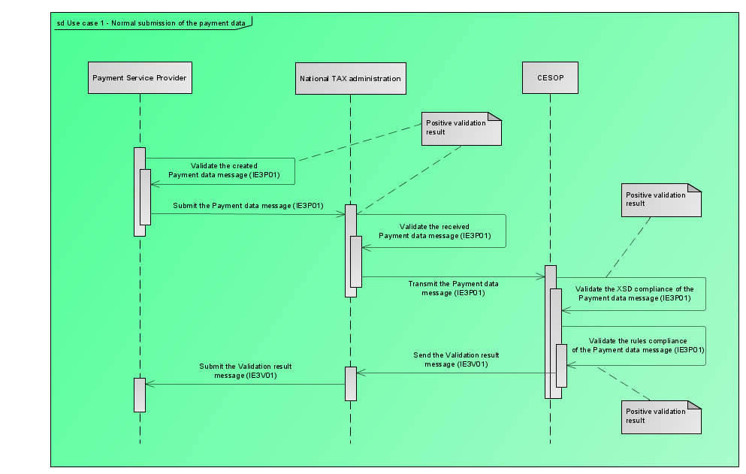
Figure 14: Detailed Use Cases - Payment Data message
The PSP can validate the message prior to submitting it to the National Tax Administration. According to this use case, the validation is positive and the PSP submits the Payment Data message to the National Tax Administration.
Then, the National Tax Administration validates the received Payment Data message. The minimal scope of this validation must be compliant to the requirements as specified in the annex of the Commission Implementation Regulation [R05]. According to this use case, the validation is positive and the National Tax Administration transmits the Payment Data message to CESOP.
Finally, CESOP validates the received Payment Data message against all applicable rules: implemented in the XSD and additional technical and business rules. According to this use case, the validation is positive and CESOP sends a positive Validation Result to the National Tax Administration.
A detailed example of this use-case is provided under section 3.4.1.

No Payment Data message
The following figure depicts the case when the PSP has no Payment Data to report for a specific period. Note that sending such message is not enforced by law but may be sent by PSPs, on a voluntary basis, to inform the National Tax Administration that they have nothing to report for the Reporting Period.
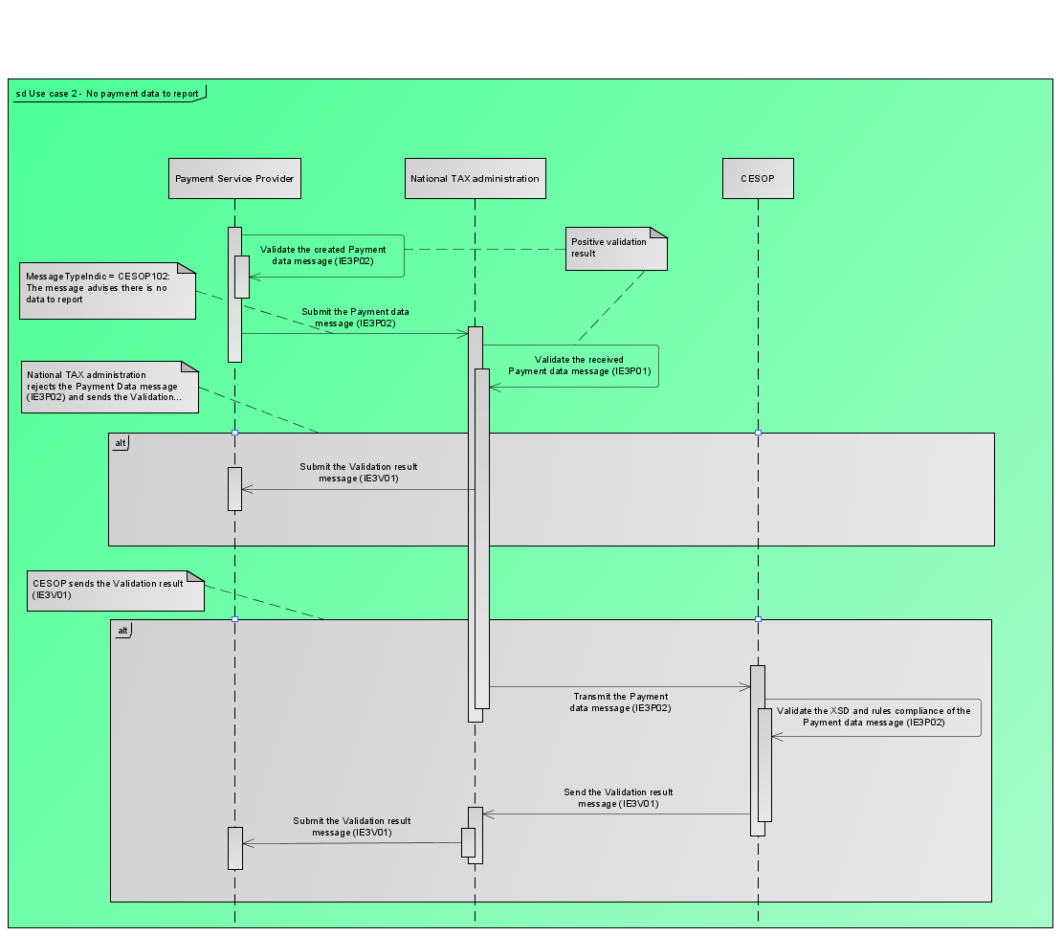
Figure 15: Detailed Use Cases - No Payment Data message
The PSP can validate the message prior to submitting it to the National Tax Administration. According to this use case, the validation is positive, and the PSP submits the No Payment Data message to the National Tax Administration.
Then, the National Tax Administration can validate the received No Payment Data message. According to this use case, the validation is positive, and the National Tax Administration transmits the Payment Data message to CESOP or not³.
In case the message is transmitted to CESOP, the system validates the received No Payment Data message against all applicable rules: implemented in the XSD and additional technical and business rules. According to this use case, the validation is positive and CESOP sends a positive Validation Result to the National Tax Administration.
A detailed example of this message is provided under section 3.4.15.

Rejection of the Payment Data message
The below sections provide the detailed use cases where the Payment Data message is rejected.

Rejection of Payment Data message by the National Tax Administration
The following figure depicts the process when the Payment Data validation fails at the National Tax Administration side.
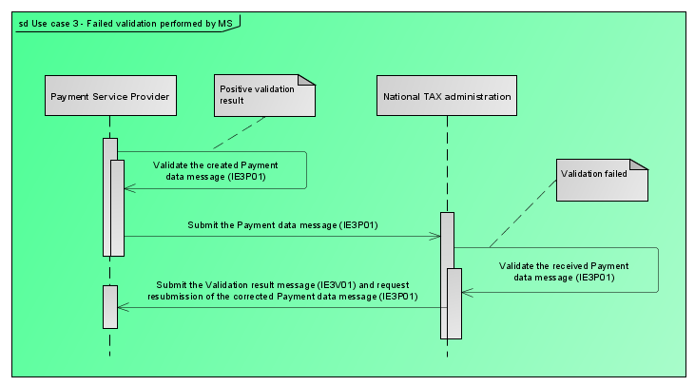
Figure 16: Detailed Use Cases – Rejection of Payment Data message by the National Tax Administration
The PSP can validate the message prior to submitting it to the National Tax Administration. According to this use case, the validation is positive, and the PSP submits the Payment Data message to the National Tax Administration.
Then, the National Tax Administration validates the received Payment Data message. The minimal scope of this validation must be compliant to the requirements as specified in the annex of the Commission Implementation Regulation [R05]. According to this use case, the validation is negative, and the message will NOT be transmitted to CESOP. The National Tax Administration will transmit the negative Validation Result with the ValidationResult element populated with ‘FULLY REJECTED’ to the PSP.
Consequently, the PSP will have to submit a new Payment Data message in which the reported errors will be corrected.
A detailed example of this use-case is provided under section 3.4.2.

Rejection of Payment Data message by CESOP
The following figure depicts the process when the Payment Data validation performed by CESOP fails. Failed validation means that either the validation of the Payment Data against the XSD failed, or the validation against the business and technical rules failed.
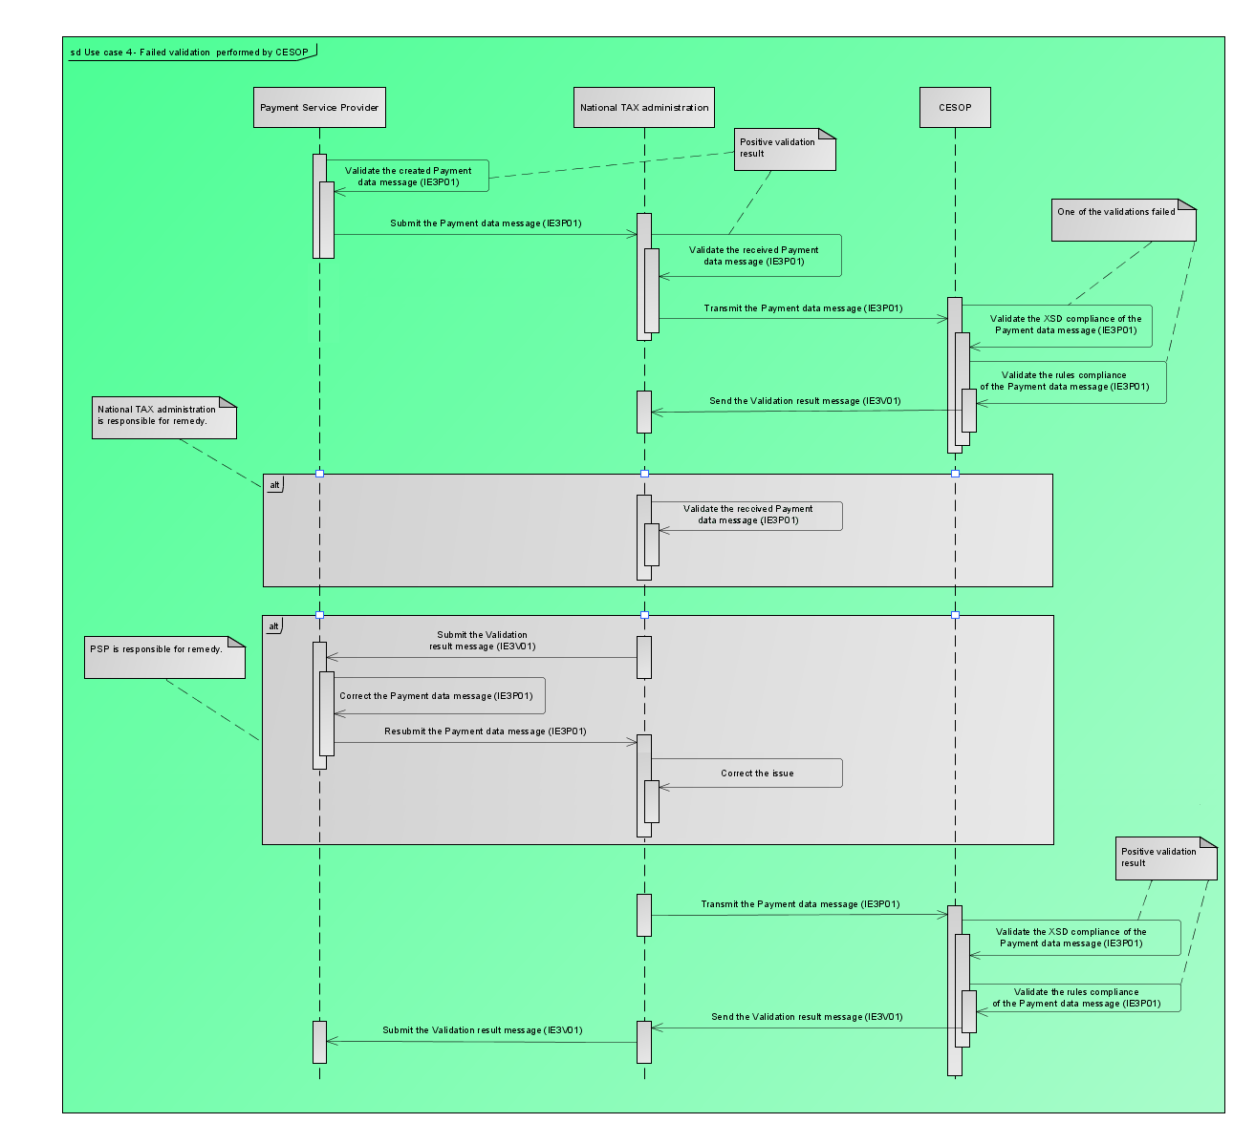
Figure 17: Detailed Use Cases – Rejection of Payment Data message by CESOP
The PSP can validate the message prior to submitting it to the National Tax Administration. According to this use case, the validation is positive, and the PSP submits the Payment Data message to the National Tax Administration.
Then, the National Tax Administration validates the received Payment Data message. The minimal scope of this validation must be compliant to the requirements as specified in the annex of the Commission Implementation Regulation [R05]. According to this use case, the validation is positive, and the National Tax Administration transmits the Payment Data message to CESOP.
Finally, CESOP validates the received Payment Data message against all applicable rules: implemented in the XSD and additional technical and business rules. According to this use case, the validation is negative. Nevertheless, there are 2 sub-cases to be considered:
- The Validation Result is such that the Payment Data message is fully rejected. CESOP will transmit the negative Validation Result with the ValidationResult element populated with ‘FULLY REJECTED’ together with the identified errors. This message will be transmitted to the National Tax Administration, or;
- The validation process is such that header and ReportingPSP data elements are positively validated, but at least one payee data element and/or at least one of its associated transaction data elements is negatively validated. This will result in a partial rejection. CESOP will transmit the negative Validation Result with the ValidationResult element populated with ‘PARTIALLY REJECTED’ together with the identified errors.

In both cases, the message will be transmitted to the National Tax Administration. Transmitting the Validation Result to the PSP is under the national responsibility.

In case the Member State is responsible of the correction (e.g., Failed validation of a certificate), the later must take the appropriate corrective action and transmit once again the Payment Data message to CESOP. A detailed example of this use-case is provided under section 3.4.2.
Otherwise, the PSP will have to take the appropriate corrective action according to the 2 sub-cases:
- When the Validation Result is ‘FULLY REJECTED’, the PSP must submit a new Payment Data message in which the reported errors will be corrected.
- When the Validation Result is ‘PARTIALLY REJECTED’, the PSP must submit a corrective Payment Data message in which the payee(s) and associated transactions on which errors have been reported are corrected and re-transmitted, considering the rules defined in section 3.3.3.1.
Detailed examples of this use-case are provided under sections 3.4.3, 3.4.4 and 3.4.5.

Submission of several Payment Data messages by the PSP for the same reporting period
The following figure depicts the process when the PSP needs to send several Payment Data messages for the same reporting period.
Note: The diagram here below depicts the case where the PSP needs to send 2 messages to the National Tax Administration, but the same can apply to more messages.
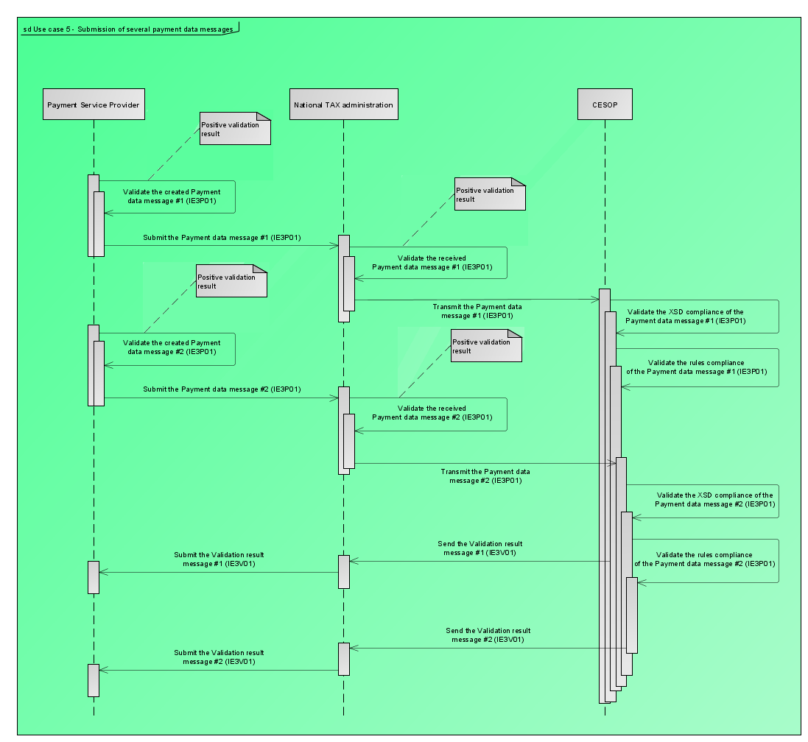
Figure 18: Detailed Use Cases - Submission of several Payment Data messages by the PSP for the same reporting period
The process follows the one depicted in section 3.2.1.1 except that the PSP might require to report several times for the same period (i.e., quarter). The two below scenarios have been identified:
- Spontaneous submission by the PSP of omitted data, as described in section 3.4.13;
- The functional split, as described in section 3.4.14.
Note that each message is processed by CESOP independently.

Additional Specifications
The below sections provide additional information regarding the messages to be exchanged between PSPs, National Tax Administrations and CESOP.

File characteristics

File size limitation
Considering the technical limitations of the AS4/TAPAS platform used for the transmission of the messages between the National Tax Administrations and CESOP, the Payment Data messages cannot exceed the maximum size of 1GB (uncompressed).
This limitation is not enforced by the recipient, but rather to avoid the enforcement of large file support to every intermediary of the Payment data transfer (e.g., PSPs and National Tax Administration proxies, operating systems, web servers). It also provides flexibility to all stakeholders on implementation models, facilitates transactional management of files intake and error management, and allows systems capacity adaptation to traffic load. PSPs are free to implement their own splitting algorithms, based on any kind of criteria (e.g. non-EU vs EU payees, split per alphabetic order).
CESOP does not impose any minimum level of splitting as long as the below-listed rules are respected. This means that the minimum granularity level of splitting is the transaction (one transaction cannot be split over two files, as the message would not be valid).
In case a PSP must submit a large number of transactions, resulting on a Payment Data message exceeding the 1GB size limit, the later shall split the submission over several files, as depicted in section 3.4.14, considering that:
- Each file must be compliant with the XSD;
- Each file will be validated separately;
- The same Reported Payee can be reported over several files if its activity results from a very large number of transactions.
The same consideration must be considered for the Validation Result message.
In case of a very large number of errors, CESOP will not split the Validation Result message but rather stop the validation process before reaching the 1GB limit. An example of this case is provided in section 3.4.17.
It is worth noting that some Member States could have lower limitations. In such a case, the PSP would have to split the submission into smaller parts.

Character set
The Payment Data message XSD accepts the ‘UTF-8’ character set, compatible with the ISO/CEI 10646 norm and capable of encoding all the characters of the Unicode. This means that all commonly used alphabets in EU are accepted (Latin, Cyrillic, Greek), but also Chinese, Japanese, Arabic, and many others.
CESOP will not transliterate the non-Latin characters and will keep the information as reported by the PSPs.

Naming convention
For the exchanged files, the following convention shall be used between the PSPs and the NTAs:
<messageType>-<quarter>-<year>-<countryMS>-<pspID>-<partNumber>
where:
- messageType = type of the message (PMT for ‘Payment Data message’, VLD for ‘Validation Result’ and PNG for ‘Ping message’).
- quarter = reported quarter.
- year = reported year.
- countryMS = host/home Member State country code (ISO-3166 Alpha 2).
- pspID = Identification of the reporting PSP (The BIC or any other business identifier code that unambiguously identifies the Payment Service Provider) according to Article 243d (1a).
- partNumber is due to the functional split (see section 3.3.1.1) or submissions of omitted data. The format is “x-y” where:
  - “y” is the total number of files exchanged by the PSP for the requested period. This includes the number of files already submitted plus the number of files yet to be submitted.
  - “x” is the number of the file in the sequence “y”.
The following examples can be given based on the above rules:
- No split needed: PMT-Q2-2025-FR-AGRIFRPPXXX-1-1
- Split needed into three parts:
  - PMT-Q2-2025-FR-AGRIFRPPXXX-1-3
  - PMT-Q2-2025-FR-AGRIFRPPXXX-2-3
  - PMT-Q2-2025-FR-AGRIFRPPXXX-3-3
Note that the unique MessageRefId, as part of the message, must differ for each part.
- If the PSP already submitted the Payment data information for a given period (e.g. PMT-Q2-2025-FR-AGRIFRPPXXX-1-1) but it appears that some information was omitted, or erroneously submitted, the PSP can then resubmit, for the same reporting period, the gap while naming the file as follows: PMT-Q2-2025-FR-AGRIFRPPXXX-2-2.
The naming convention has been defined as a good practice to ease the communication between the National Tax Administrations and the PSPs. This has no business value and therefore is not required by the CESOP central system. In other words, the CESOP central system will always process each file independently, whatever the filename.

Correlation mechanism
The present section provides information on how to correlate messages and payees. This correlation mechanism is especially used in the correction of messages, further described in section 3.3.3.

Correlation of the messages
For the correlation of the messages, two elements under the MessageSpec element are used:
- The MessageRefId element, capturing the sender’s unique identifier of the message being sent. This identifier allows to identify the specific message later as in the case of corrections.
As indicated in section 2.2.3.2, the element takes the form of a UUID version 4 identifier.

- The CorrMessageRefId element, corresponds to the correlation Message Reference ID element allowing to correlate the current message with the dependent one, i.e., the MessageRefId of the correlated message.
Messages can be correlated in the following cases:
- Correlation between the Payment Data message and the related Validation Result message:
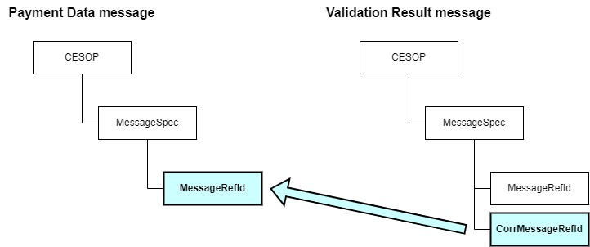
Figure 19: Correlation of the messages – Examples – Validation Result message
- Correlation between a Payment Data message and the related Payment Data correction message (see section 3.3.3 for more details):

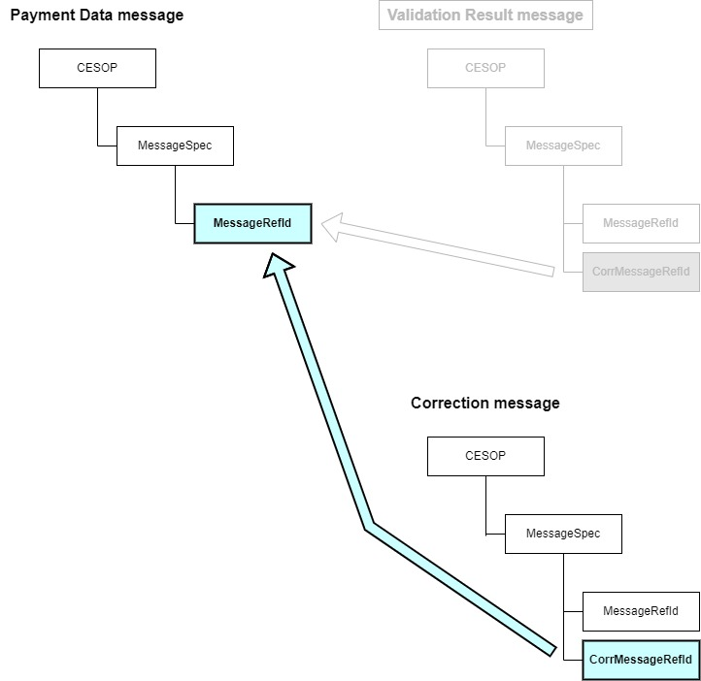
Figure 20: Correlation of the messages – Examples – Correction message
As mentioned above, the MessageRefId must be unique for the sender. This is applicable for the PSPs and for CESOP. However, the National Tax Administration is an exception, as they only retransmit the messages coming either from the PSP or from CESOP without any change. The message is still the same, so the National Tax Administration does not change the value of the MessageRefId element, nor the value of the CorrMessageRefId element.
Exceptional case is when the National Tax Administration validates the Payment Data message, and the Validation Result is negative. In this case, the National Tax Administration does not transmit the Payment Data message further to CESOP, but rather generates the Validation Result message to be provided to the PSP. In this case the MessageRefId element will have a new value assigned by the National Tax Administrations and the CorrMessageRefId element will contain the value of the MessageRefId from the received Payment Data message.

Correlation of Payees
The correlation of Payees aims to correlate one Reported Payee from a message to the same Reported Payee in another message (for instance, to correct it). Such correlation is established using the DocSpec element, where the following sub-elements can be provided:
- The DocTypeIndic element, allowing to provide the type of data that is sent (further described in section 3.3.3.2);

- The DocRefId element, capturing the Reported Payee’s unique identifier. This element must be unique in time and space per PSP, per National Tax Administration, and per reported period.
As indicated in section 2.2.4.36, the element takes the form of a UUID version 4 identifier7;

- The CorrDocRefId element, allowing the correlation of the Reported Payee within the correlated message, i.e. containing the DocRefId of the correlated Reported Payee;

- The CorrMessageRefId element, that shall not be populated in any case, as the PSP must fill this element at message level (in the MessageSpec element, see section 3.3.2.1).
Note that, for the Validation Result message, the DocRefId element allows to identify the element for which validation errors have been detected.
Reported Payees can be correlated in the following cases:
- Correlation of a Reported Payee sent within the Payment Data message and the related Validation Result message (to identify the erroneous record(s) and the related error):

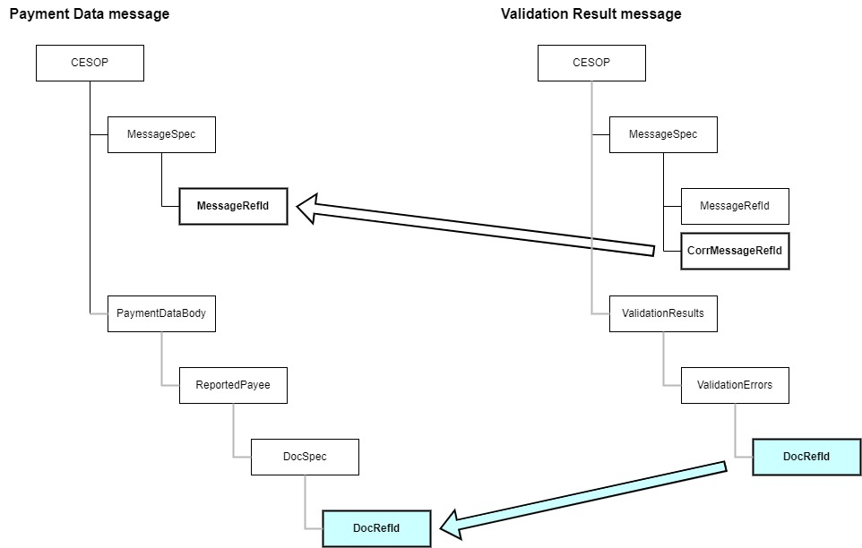
Figure 21: Correlation of the Payees – Examples – Validation Result message
- Correlation of Reported Payees between a Payment Data message and the related Payment Data correction message (see section 3.3.3 for more details):
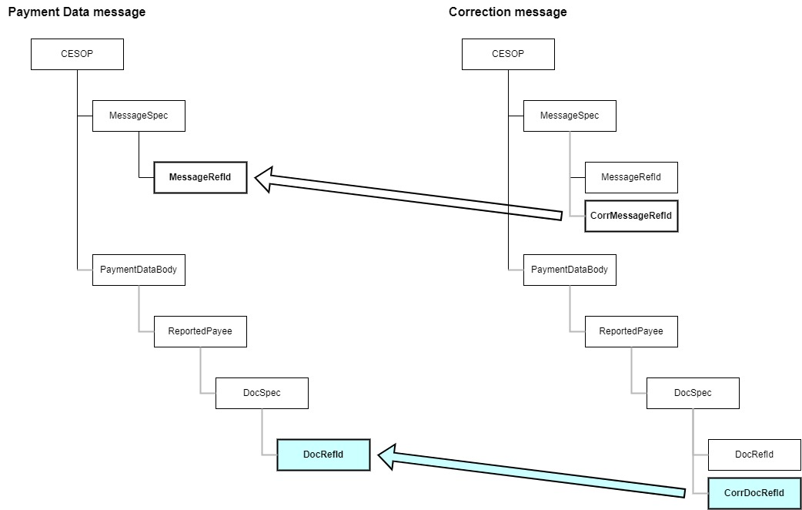
Figure 22: Correlation of the Payees – Examples – Correction message

Correlation errors
The present section described the error codes that may be raised in case of correlation issues and how PSPs must solve those errors.
10010: “MessageRefID is not unique”:
This error indicates that the UUID provided in the MessageRefId element has already been used in a previous submission. In such a case, the second message is rejected by CESOP, and nothing is stored in the CESOP data store, as depicted in section 3.4.16. This can be due to:
- A double submission of a same Payment Data message. In that case, nothing has to be performed by the PSP or the National Tax Administration;
- A UUID collision as explained in section 7.2 or the reuse of an already used UUID. In that case, the PSP shall resubmit the rejected message with a new UUID.
10040: “Wrong CorrMessageRefID”:
This error indicates that the value provided in the CorrMessageRefId element does not refer to any recorded MessageRefId. In such a case, the PSP shall resubmit the correction message with the correct correlation message reference ID.
20010: “DocRefID is not unique within the message”:
This error indicates that several different Reported Payees, in the same message, have the same DocRefId value. This can be due to a technical error in the message generation, or a UUID collision (as explained in section 7.2). In such a case, the error will only be triggered for the repeated identifiers (i.e. not the first occurrence). The PSP shall resubmit the Payment Data message with new UUIDs for the erroneous Reported Payee(s).
20020: “DocRefID is not unique within the system”:
This error indicates that the DocRefId element has already been used to identify a Reported Payee in another Payment Data message. This can be due to a technical error in the message generation, or a UUID collision (as explained in section 7.2). In such a case, the PSP shall resubmit the Payment Data message with a new UUID for the erroneous Reported Payee(s).
20040: “Wrong CorrDocRefId value”:
This error indicates that the value provided in the CorrDocRefId element does not refer to any recorded DocRefId. In such a case, the PSP shall resubmit the correction message with the correct correlation reported payee reference ID (see section 3.3.3.1).
20060: “Missing CorrDocRefId”:
In a correction message, the CorrDocRefId element must be provided to indicate to which previously Reported Payee the correction or deletion refers to. In such a case, the PSP shall resubmit the correction message with the correct correlation reported payee reference ID (see section 3.3.3.1).
20070: “CorrDocRefId no longer valid”:
This error occurs if the CorrDocRefId element refers to an already corrected or deleted Reported Payee and is triggered only when the correction/deletion message has already been successfully validated. In such a case, the PSP shall resubmit the correction message with the correct correlation reported payee reference ID (see section 3.3.3.1).
For example, the following files are submitted and transmitted to the CESOP central system:

- A first valid initial message;
- A second valid correction message, correlated to the first initial message.
The error 20070 will be triggered in case a third correction message is submitted and transmitted while correlating to the first initial message (instead of the second correction message).

Correction of messages
CESOP supports a correction mechanism for the exchanged Payment Data messages.
As the National Tax Administration is not allowed to modify the Payment Data, the sender of the message is the PSP and the final receiver is CESOP, while the National Tax Administration only transmits the corrected Payment Data received from the PSPs. Note that if the validation of the Payment Data received by the National Tax Administration fails for a technical reason, the National Tax Administration may address the technical issue, re-validates the Payment Data, and transmit it to CESOP (refer to the example provided in section 3.4.3).
It is worth to note that the correction mechanism implemented in CESOP only allows to correct, in one correction file, elements from one single previously received and accepted file. This means that it is not possible to correct, in one single correction file, Reported Payees (or underlying Reported Transactions) initially reported in different Payment Data messages.

Correction rules
To correct the reporting and/or sending PSP information, a correction message must be submitted, where the PaymentDataBody element must be populated with at least the ReportingPSP element, meaning that the ReportedPayee element can be omitted. The correction of a PSP is illustrated in section 3.4.9.
Note that CESOP prevents PSPs to submit a message aiming to delete its own information. Indeed, as regarding Art.2I of the Implementation Regulation 2022/1504 [R05], among the tasks of the Commission for technically managing CESOP, the following are listed: “establishing, keeping and maintaining a list of payment service providers who reported data pursuant to Article 24b(1) of Regulation (EU) No 904/2010, according to the data provided by Member States”.
At Reported Payee level, corrections must be performed based on the correlation mechanisms explained in section 3.3.2. In case of error, the related reported payee’s data including all its underlying transactions will be rejected, thus not stored in the central system and need to be corrected. The correction message must thus include all the corrected data, i.e. the reported payee information and all its transactions, as described in the examples provided in sections 3.4.5 (for erroneous cases) or 3.4.10 (for spontaneous correction). In case of spontaneous correction, the CESOP central system will delete all transactions stored under that reported payee and replace them with the ones provided in the correction message.
Also note that:
- Corrections cannot be made on a reported payee that was submitted in a message that has been fully rejected. Indeed, those messages are not processed by CESOP and so the data included in such messages are not recorded (see example in section 3.4.4);

- Otherwise, if the correction message is correlated to a partially rejected or a successfully validated message:

  - PSPs are, either, allowed to correlate to any payee previously reported, as long as the message does not breach any rule defined in the present section or in sections 4 and 5 (see examples in sections 3.4.5, 3.4.10 and 3.4.18);
  - Or, if the reported payee was never successfully validated and thus is not stored by CESOP, PSPs can send a new Payment Data message to report the rejected data as new records, without any correlation with the partially rejected message (similar to the example in section 3.4.4).

- It is allowed to submit a correction message containing corrections on several reported payees, 3both rejected and accepted, as long as the correction message refers to the same correlated message. This case is illustrated in both sections 3.4.10 and 3.4.18;

- In case the payee must be deleted, only mandatory fields need to be provided under the ReportedPayee element, while the underlying transactions must not be provided (refer to the business rule RP-BR-0090). This case is illustrated in section 3.4.11;

- The correction mechanism on reported transactions operates as follows:
  - To add only new transactions to a Reported Payee, such data must be sent via a new Payment Data message, where only these new transactions are to be reported (as depicted in section 3.4.13);
  - To correct a subset of transactions that were previously reported and accepted by CESOP for a Reported Payee, PSPs can delete this Reported Payee and submit a new Payment Data message (as depicted in section 3.4.12) or submit a spontaneous correction message (as depicted in section 3.4.10)
  - To delete all the transactions that were previously reported and accepted by CESOP for a Reported Payee, PSPs must submit a correction message deleting this Reported Payee (as depicted in section 3.4.11).

Correction message structure
Correction messages have essentially the same structure as initial Payment Data messages, as it follows the same XSD and must be built as described in sections 3.3.2.1 and 3.3.2.2.
In those Payment Data messages, the MessageTypeIndic element specifies the purpose of the message from a CESOP point of view:
- CESOP100: The message contains new data. This code shall be used in case the reported data has never been (successfully) reported or was deleted by the PSP during the reporting period;

- CESOP101: The message contains corrections or deletions of previously sent data. This code shall be used to correct reported data that has been accepted by CESOP;

- CESOP102: The message indicates there is no data to report. This code must be used by PSPs to inform the National Tax Administration that there is no data to report for the reporting period.
Within the DocSpec element, the DocTypeIndic specifies the operation over the element:
- CESOP1: New Data – the data was not accepted by CESOP before. This code may only be used in messages where MessageTypeIndic = CESOP100;

- CESOP2: Corrected Data – the data refers to previously accepted data to be corrected. This code may only be used in messages where MessageTypeIndic = CESOP101;

- CESOP3: Deletion of Data – the data refers to previously accepted data to be deleted. This code may only be used in messages where MessageTypeIndic = CESOP101.
For examples of correlations and corrections, please refer to section 3.4.

Refunds
It is important to note that the payer of a ‘payment’ remains the payer of the corresponding ‘payment refund’ and the payee of a ‘payment’ remains the payee of the corresponding ‘payment refund’, if any. In other words:
- In a ‘payment’, the Payer gives the money to the Payee. Consequently, the element 'PayerMS' will contain the 'MS Origin Payment' as described in Box 11 of the implementing regulation;
- In a ‘payment refund, the Payee gives money back to the Payer. Consequently, the element 'PayerMS' will contain the 'MS Destination refund' as described in Box 12 of the implementing regulation.
The way to report a ‘payment refund’ is the same as the way to report its related payment, considering that:
- The IsRefund attribute defines if the reported transaction is either:
  - A payment (‘false’ or ‘0’), or,
  - A payment refund (‘true’ or ‘1’).
This attribute is optional. If not provided, the value ‘false’ will be assumed.
- The Amount element shall be:
  - Positive for a payment;
  - Negative for a payment refund.
- The CorrTransactionIdentifier element allows to link the payment refund to its initial payment by containing the TransactionIdentifier of the latter. This element is optional as not necessarily available to the reporting PSP.
- Although it is recommended to use different identifiers for a payment and its refund, the reporting PSP might reuse the TransactionIdentifier of the initial payment in its refund. A mechanism on CESOP side interprets the latter and infers the link between the transactions.
In case of a partial refund, the absolute value of the amount of the refund will be lower than the absolute value of the amount of the related payment.

Examples of message exchanges scenarios
The below sub-sections provide some examples of message exchanges scenarios between the PSP, the National Tax Administrations (NTA) and CESOP.
Note that, in the below examples, it is assumed that the outcome of the CESOP validation is always transmitted to the National Tax Administration and subsequently provided to the PSP.

Acceptance of the Payment Data message by CESOP
The following exchange scenario highlights the use case mentioned in section 3.2.1.1:
- Submitting a Payment Data message by the PSP, subsequently transmitted by the National Tax Administration to CESOP:
File name | PMT-Q1-2025-FR-AGRIFRPPXXX-1-1.xml
MessageType | PMT
MessageTypeIndic | CESOP100
MessageRefId | 005963c0-e17b-4b4e-a3fd-e55685906930
CorrMessageRefId | Not provided

- CESOP system responding with a positive Validation Result message (as described in section 3.1.3.2.1):
File name | VLD-Q1-2025-FR-AGRIFRPPXXX-1-1.xml
MessageType | VLD
MessageTypeIndic | CESOP100
MessageRefId | 9f393754-228f-434a-9024-be8cb336aabd
CorrMessageRefId | 005963c0-e17b-4b4e-a3fd-e55685906930
ValidationResult | VALIDATED

Full rejection of the Payment Data message by the National Tax Administration, and subsequent correction by the PSP
The following exchange scenario highlights the use case mentioned in section 3.2.2.1:
- Submitting a Payment Data message by the PSP to the National Tax Administration:
File name | PMT-Q1-2024-AT-BTVAAT22XXX-1-1.xml
MessageType | PMT
MessageTypeIndic | CESOP100
MessageRefId | b7c60422-6c20-43db-a013-b3724e946592
CorrMessageRefId | Not provided

- National Tax Administration responding to the PSP with a full rejection Validation Result message (as described in section 3.1.3.2.2):
File name | VLD-Q1-2024-AT-BTVAAT22XXX-1-1.xml
MessageType | VLD
MessageTypeIndic | CESOP100
MessageRefId | d4f2fc24-8d8d-43fb-9b76-ed3fe53827e3
CorrMessageRefId | b7c60422-6c20-43db-a013-b3724e946592
ReportingPeriod | Q1 2024
ValidationResult | FULLY REJECTED

- Submitting a new Payment Data message by the PSP correcting the previous one, subsequently transmitted by the National Tax Administration to CESOP as an initial message (since nothing has been transmitted to CESOP):
File name | PMT-Q1-2024-AT-BTVAAT22XXX-1-1.xml
MessageType | PMT
MessageTypeIndic | CESOP100
MessageRefId | 12d8cb1a-0eeb-49eb-946c-1f863f66089a
CorrMessageRefId | Not provided

- CESOP system responding with a positive Validation Result message:
File name | VLD-Q1-2024-AT-BTVAAT22XXX-1-1.xml
MessageType | VLD
MessageTypeIndic | CESOP100
MessageRefId | aec634a7-10eb-4dfb-a6fe-15018552073d
CorrMessageRefId | 12d8cb1a-0eeb-49eb-946c-1f863f66089a
ValidationResult | VALIDATED

Full rejection of the Payment Data message by CESOP for technical errors for which the NTA is responsible of
The following example depicts the case where the National Tax Administration is itself responsible of the error. This could happen due to technical issues such as a failed signature check at CESOP level.
- Submitting a Payment Data message by the PSP, subsequently transmitted by the National Tax Administration to CESOP:
File name | PMT-Q1-2026-IE-BNPAIE2DXXX-1-1.xml
MessageType | PMT
MessageTypeIndic | CESOP100
MessageRefId | 4bee4bea-3179-4bf4-9fe2-50f405a32071
CorrMessageRefId | Not provided

- CESOP system responding with a full rejection Validation Result message (as described in section 3.1.3.2.2):
File name | VLD-Q1-2026-IE-BNPAIE2DXXX-1-1.xml
MessageType | VLD
MessageTypeIndic | CESOP100
MessageRefId | 90f66edc-c688-4739-bd50-679a08403287
CorrMessageRefId | 4bee4bea-3179-4bf4-9fe2-50f405a32071
ValidationResult | FULLY REJECTED
ValidationErrors
ErrorCode | 50040
ErrorShortDesc | Failed Signature Check
ErrorDescription | The CESOP system could not validate the digital signature on the referenced file.

At this stage, the National Tax Administration identifies the technical issue and corrects it.
As the National Tax Administration is not allowed to tamper the data within the Payment Data message, the later shall be retransmitted without any modification, meaning the exact same message shall be re-transmitted to CESOP.

- Retransmitting the same Payment Data message by the National Tax Administration to CESOP:
File name | PMT-Q1-2026-IE-BNPAIE2DXXX-1-1.xml
MessageType | PMT
MessageTypeIndic | CESOP100
MessageRefId | 4bee4bea-3179-4bf4-9fe2-50f405a32071
CorrMessageRefId | Not provided

Full rejection of the Payment Data message by CESOP, and subsequent correction by the PSP
The following exchange scenario highlights the use case mentioned in section 3.2.2.2. This scenario can occur if CESOP detects at least one error or a set of errors leading to a full rejection:
- Submitting a Payment Data message by the PSP, subsequently transmitted by the National Tax Administration to CESOP:
File name | PMT-Q4-2024-BE-BCMCBEBBXXX-1-1.xml
MessageType | PMT
MessageTypeIndic | CESOP100
MessageRefId | 2b0b2919-fb2c-4aa6-ba81-f5e8216c7d0a
CorrMessageRefId | Not provided

- CESOP system responding with a full rejection Validation Result message (as described in section 3.1.3.2.2):
File name | VLD-Q4-2024-BE-BCMCBEBBXXX-1-1.xml
MessageType | VLD
MessageTypeIndic | CESOP100
MessageRefId | c57eb624-878e-48b3-93a8-365cc5c93aad
CorrMessageRefId | 2b0b2919-fb2c-4aa6-ba81-f5e8216c7d0a
ValidationResult | FULLY REJECTED

In case of full rejection at CESOP level, nothing is stored in CESOP. Consequently, the data of the fully rejected message shall be resubmitted as a new Payment Data message by the PSP:
- Submitting a new Payment Data message by the PSP correcting the previous one, subsequently transmitted by the National Tax Administration to CESOP:
File name | PMT-Q4-2024-BE-BCMCBEBBXXX-1-1.xml
MessageType | PMT
MessageTypeIndic | CESOP100
MessageRefId | 102a241d-9f1e-43b5-96c7-6a3455df40eb
CorrMessageRefId | Not provided

- CESOP system responding with a positive Validation Result message (as described in section 3.1.3.2.1):
File name | VLD-Q4-2024-BE-BCMCBEBBXXX-1-1.xml
MessageType | VLD
MessageTypeIndic | CESOP100
MessageRefId | f70117d1-6aac-4fb3-a1cc-9b76545ed0d0
CorrMessageRefId | 102a241d-9f1e-43b5-96c7-6a3455df40eb
ValidationResult | VALIDATED

Partial rejection of a Payment Data message and subsequent correction by the PSP
This scenario can occur if errors are detected in the ReportedPayee element. The following example depicts the case where four Payees are initially reported, two of them (“Reported Payee 1” and “Reported Payee 4”) being erroneous:
- Submitting a Payment Data message by the PSP, subsequently transmitted by the National Tax Administration to CESOP:
File name | PMT-Q3-2024-FI-HOLVFIHHXXX-1-1.xml
MessageType | PMT
MessageTypeIndic | CESOP100
MessageRefId | 71e71d18-d38c-4847-8e08-aad4e4f6af48
CorrMessageRefId | Not provided
Reported Payee 1
DocSpec.DocTypeIndic | CESOP1
DocSpec.DocRefId | 8969aa30-6da6-4ed9-aa5e-68e588ad4a76
DocSpec.CorrDocRefId | Not provided
Reported Payee 2
DocSpec.DocTypeIndic | CESOP1
DocSpec.DocRefId | adc5c123-e36f-4de7-b4ad-cb4737896ca9
DocSpec.CorrDocRefId | Not provided
Reported Payee 3
DocSpec.DocTypeIndic | CESOP1
DocSpec.DocRefId | d3f37b25-90b1-4c56-b520-c0e55354ab0e
DocSpec.CorrDocRefId | Not provided
Reported Payee 4
DocSpec.DocTypeIndic | CESOP1
DocSpec.DocRefId | 1fb11346-0537-4aac-b14c-65aead077670
DocSpec.CorrDocRefId | Not provided

- CESOP responding with a partial rejection Validation Result message (as described in section 3.1.3.2.3):
File name | VLD-Q3-2024-FI-HOLVFIHHXXX-1-1.xml
MessageType | VLD
MessageTypeIndic | CESOP100
MessageRefId | 5f4f5e32-b464-4120-acd8-fbabbce52e3d
CorrMessageRefId | 71e71d18-d38c-4847-8e08-aad4e4f6af48
ValidationResult | PARTIALLY REJECTED
ValidationErrors (Reported Payee 1)
DocRefId | 8969aa30-6da6-4ed9-aa5e-68e588ad4a76
ValidationErrors (Reported Payee 4)
DocRefId | 1fb11346-0537-4aac-b14c-65aead077670

Note that at this stage, “Reported Payee 2” and “Reported Payee 3” are accepted and stored in CESOP. They will not have to be provided in the correction message.
- Submitting a Payment Data correction message by the PSP, subsequently transmitted by the National Tax Administration to CESOP:
File name | PMT-Q3-2024-FI-HOLVFIHHXXX-1-1.xml
MessageType | PMT
MessageTypeIndic | CESOP101
MessageRefId | 47f657d2-050e-4e1e-8123-f12f4aa657f9
CorrMessageRefId | 71e71d18-d38c-4847-8e08-aad4e4f6af48
Reported Payee 1
DocSpec.DocTypeIndic | CESOP2
DocSpec.DocRefId | 35af3cee-8b89-4438-95ed-d5111b82016a
DocSpec.CorrDocRefId | 8969aa30-6da6-4ed9-aa5e-68e588ad4a76
Reported Payee 4
DocSpec.DocTypeIndic | CESOP2
DocSpec.DocRefId | e31f3da1-108e-4854-9566-350be76e000b
DocSpec.CorrDocRefId | 1fb11346-0537-4aac-b14c-65aead077670

Note: Instead of submitting a correction message, the PSP can also submit a new Payment Data message containing “Reported Payee 1” and “Reported Payee 4” and empty value for the CorrMessageRefId element.

- CESOP system responding with a positive Validation Result message (as described in section 3.1.3.2.1):
File name | VLD-Q3-2024-FI-HOLVFIHHXXX-1-1.xml
MessageType | VLD
MessageTypeIndic | CESOP100
MessageRefId | d182efee-fca2-4727-86d2-f1a48119b468
CorrMessageRefId | 47f657d2-050e-4e1e-8123-f12f4aa657f9
ValidationResult | VALIDATED

Partial rejection of a Payment Data message with all Payees breaching a business rule, and subsequent correction by the PSP
This scenario occurs when errors are detected in all the ReportedPayee elements included in the initial Payment Data message. The following example depicts the case where two Payees are initially reported, both being erroneous:
- Submitting a Payment Data message by the PSP, subsequently transmitted by the National Tax Administration to CESOP:
File name | PMT-Q1-2027-BE-GEBABEBX-1-1.xml
MessageType | PMT
MessageTypeIndic | CESOP100
MessageRefId | 10ca990f-ca5f-4a21-a14e-e2d2af8c3d6b
CorrMessageRefId | Not provided
Reported Payee 1
DocSpec.DocTypeIndic | CESOP1
DocSpec.DocRefId | 9165008d-2cee-4044-bf7d-7f132812d063
DocSpec.CorrDocRefId | Not provided
Reported Payee 2
DocSpec.DocTypeIndic | CESOP1
DocSpec.DocRefId | 8cc4c16a-34e3-420a-98d5-f7525475d9ef
DocSpec.CorrDocRefId | Not provided

- CESOP responding with a partial rejection Validation Result message (as described in section 3.1.3.2.3):
File name | VLD-Q1-2027-BE-GEBABEBX-1-1.xml
MessageType | VLD
MessageTypeIndic | CESOP100
MessageRefId | c00926f0-6f9d-432b-bbe5-44e55c3090af
CorrMessageRefId | 10ca990f-ca5f-4a21-a14e-e2d2af8c3d6b
ValidationResult | PARTIALLY REJECTED
ValidationErrors (Reported Payee 1)
DocRefId | 9165008d-2cee-4044-bf7d-7f132812d063
ValidationErrors (Reported Payee 2)
DocRefId | 8cc4c16a-34e3-420a-98d5-f7525475d9ef

Because the two payees have been rejected by CESOP, the PSP is expected to re-submit the information in one or multiple correction message(s). At this stage, only the PSP data is successfully saved and considered as valid.
- Submitting a Payment Data correction message by the PSP, subsequently transmitted by the National Tax Administration to CESOP:
File name | PMT-Q1-2027-BE-GEBABEBX-1-1.xml
MessageType | PMT
MessageTypeIndic | CESOP101
MessageRefId | 3b8fc478-b989-4dca-aa8b-d827d4fa92ca
CorrMessageRefId | 10ca990f-ca5f-4a21-a14e-e2d2af8c3d6b
Reported Payee 1
DocSpec.DocTypeIndic | CESOP2
DocSpec.DocRefId | ca359f04-86b9-472a-bd56-a305265b72db
DocSpec.CorrDocRefId | 9165008d-2cee-4044-bf7d-7f132812d063
Reported Payee 2
DocSpec.DocTypeIndic | CESOP2
DocSpec.DocRefId | 59b620f1-da27-4097-9fea-4763e8c0fff9
DocSpec.CorrDocRefId | 8cc4c16a-34e3-420a-98d5-f7525475d9ef

Note: Instead of submitting a correction message, the PSP can also submit one or multiple new Payment Data message(s) containing “Reported Payee 1” and “Reported Payee 2”.

- CESOP system responding with a positive Validation Result message (as described in section 3.1.3.2.1):
File name | VLD-Q1-2027-BE-GEBABEBX-1-1.xml
MessageType | VLD
MessageTypeIndic | CESOP100
MessageRefId | f337186b-a0cf-4247-b8bf-77bb415ab4d2
CorrMessageRefId | 3b8fc478-b989-4dca-aa8b-d827d4fa92ca
ValidationResult | VALIDATED

Complex case with full rejection at CESOP level, then full rejection at NTA level
The following example depicts the case when the Payment Data message is fully rejected by CESOP, then the new submission with corrected data is fully rejected at National Tax Administration level:
- Submitting a Payment Data message by the PSP, subsequently transmitted by the National Tax Administration to CESOP:
File name | PMT-Q4-2026-SI-KSPKSI22XXX-1-1.xml
MessageType | PMT
MessageTypeIndic | CESOP100
MessageRefId | 1405f2b6-6453-4f08-a920-a409652bb448
CorrMessageRefId | Not provided
ReportingPSP.PSPId | KSPKSI22XXX
ReportingPSP.Name | BANKA SPARKASSE D.D.

- CESOP system responding with a full rejection Validation Result message (as described in section 3.1.3.2.2):
File name | VLD-Q4-2026-SI-KSPKSI22XXX-1-1.xml
MessageType | VLD
MessageTypeIndic | CESOP100
MessageRefId | fb02f41c-1b07-4315-a31b-3eac44e59b38
CorrMessageRefId | 1405f2b6-6453-4f08-a920-a409652bb448
ValidationResult | FULLY REJECTED

- Submitting a new Payment Data message by the PSP correcting the previous one (first try):
File name | PMT-Q4-2026-SI-KSPKSI22XXX-1-1.xml
MessageType | PMT
MessageTypeIndic | CESOP100
MessageRefId | 99c24d22-20eb-44f1-9a2b-ffab7f8123e0
CorrMessageRefId | Not provided
ReportingPSP.PSPId | KSPKSI22XXX
ReportingPSP.Name | BANKA SPARKASSE D.D.

- National Tax Administration responding with a full rejection Validation Result message (as described in section 3.1.3.2.2):
File name | VLD-Q4-2026-SI-KSPKSI22XXX-1-1.xml
MessageType | VLD
MessageTypeIndic | CESOP100
MessageRefId | e3c9e199-948f-49f8-bdec-579558d12884
CorrMessageRefId | 99c24d22-20eb-44f1-9a2b-ffab7f8123e0
ValidationResult | FULLY REJECTED

- Submitting a new Payment Data message by the PSP correcting the previous one (second try):
File name | PMT-Q4-2026-SI-KSPKSI22XXX-1-1.xml
MessageType | PMT
MessageTypeIndic | CESOP100
MessageRefId | 2279d58b-232a-4ed3-a088-50de580bccbf
CorrMessageRefId | Not provided
ReportingPSP.PSPId | KSPKSI22XXX
ReportingPSP.Name | BANKA SPARKASSE D.D.

Complex case with partial rejection at CESOP level, then full rejection at NTA level
The following example depicts the case when the Payment Data message is partially rejected by CESOP, then the new submission with corrected data is fully rejected at National Tax Administration level:
- Submitting a Payment Data message by the PSP, subsequently transmitted by the National Tax Administration to CESOP:
File name | PMT-Q1-2027-SK-HYMOSK21XXX-1-1.xml
MessageType | PMT
MessageTypeIndic | CESOP100
MessageRefId | 59548207-34ae-4c65-8c2b-28e50a560bfc
CorrMessageRefId | Not provided
ReportingPSP.PSPId | HYMOSK21XXX
ReportingPSP.Name | MOBIS SLOVAKIA S.R.O.
Reported Payee 1
DocSpec.DocTypeIndic |  | CESOP1
DocSpec.DocRefId |  | e9464d38-c4c2-45e0-9eca-22b4793aa36c
DocSpec.CorrDocRefId |  | Not provided
Reported Payee 2
DocSpec.DocTypeIndic |  | CESOP1
DocSpec.DocRefId |  | 5150ad45-1721-43c7-9a12-70466adda3c7
DocSpec.CorrDocRefId |  | Not provided

- CESOP system responding with a partial rejection Validation Result message (as described in section 3.1.3.2.3):
File name | VLD-Q1-2027-SK-HYMOSK21XXX-1-1.xml
MessageType | VLD
MessageTypeIndic | CESOP100
MessageRefId | cb109b18-fb20-43c7-a732-0480a3b72040
CorrMessageRefId | 59548207-34ae-4c65-8c2b-28e50a560bfc
ValidationResult | PARTIALLY REJECTED
ValidationErrors(Reported Payee 2)
DocRefId | 5150ad45-1721-43c7-9a12-70466adda3c7

At this stage, ‘Reported Payee 1’ is accepted and stored in the CESOP data store, and ‘Reported Payee 2’ is rejected and needs to be corrected by the PSP.

- Submitting a correction message by the PSP correcting ‘Reported Payee 2’ (first try):
File name | PMT-Q1-2027-SK-HYMOSK21XXX-1-1.xml
MessageType | PMT
MessageTypeIndic | CESOP101
MessageRefId | bd674627-6c45-498f-8208-6fdc455cefea
CorrMessageRefId | 59548207-34ae-4c65-8c2b-28e50a560bfc
ReportingPSP.PSPId | HYMOSK21XXX
ReportingPSP.Name | MOBIS SLOVAKIA S.R.O.
Reported Payee 2
DocSpec.DocTypeIndic |  | CESOP2
DocSpec.DocRefId |  | 4391fce7-655f-496e-b78e-0631c63d6179
DocSpec.CorrDocRefId |  | 5150ad45-1721-43c7-9a12-70466adda3c7

- National Tax Administration responding with a full rejection Validation Result message (as described in section 3.1.3.2.2):
File name | VLD-Q1-2027-SK-HYMOSK21XXX-1-1.xml
MessageType | VLD
MessageTypeIndic | CESOP101
MessageRefId | a6beb855-1527-4d67-aaeb-f621504b3ed0
CorrMessageRefId | bd674627-6c45-498f-8208-6fdc455cefea
ValidationResult | FULLY REJECTED

- Submitting a correction message by the PSP correcting ‘Reported Payee 2’ (second try):
File name | PMT-Q1-2027-SK-HYMOSK21XXX-1-1.xml
MessageType | PMT
MessageTypeIndic | CESOP101
MessageRefId | 796777fc-3318-48c8-a052-244c3a88cd4f
CorrMessageRefId | 59548207-34ae-4c65-8c2b-28e50a560bfc
ReportingPSP.PSPId | HYMOSK21XXX
ReportingPSP.Name | MOBIS SLOVAKIA S.R.O.
Reported Payee 2
DocSpec.DocTypeIndic |  | CESOP2
DocSpec.DocRefId |  | 4391fce7-655f-496e-b78e-0631c63d6179
DocSpec.CorrDocRefId |  | 5150ad45-1721-43c7-9a12-70466adda3c7

As the first try of correction has been fully rejected, the second try of correction shall refer to the initial message as it is the last message in which the payee was reported and the message was successfully processed (i.e. not fully rejected).

Spontaneous correction of the PSP information
The following example depicts the case when a correction is needed on the SendingPSP and/or ReportingPSP information:
- Submitting a Payment Data message by the PSP, subsequently transmitted by the National Tax Administration to CESOP:
File name | PMT-Q3-2026-FR-AGRIFRPPXXX-1-1.xml
MessageType | PMT
MessageTypeIndic | CESOP100
MessageRefId | 147dbc3c-8428-4921-849d-9edea7bac40e
CorrMessageRefId | Not provided
SendingPSP.PSPId | AGRIFRPPXXX
SendingPSP.Name | Credit Agricole
ReportingPSP.PSPId | AGRIFRPP861
ReportingPSP.Name | Credit Agricole Metz

- CESOP system responding with a positive Validation Result message (as described in section 3.1.3.2.1):
File name | VLD-Q3-2026-IT-BPPIITRRXXX-1-1.xml
MessageType | VLD
MessageTypeIndic | CESOP100
MessageRefId | c06309d0-f9d6-44d6-8eab-e820309a0ae5
CorrMessageRefId | 147dbc3c-8428-4921-849d-9edea7bac40e
ValidationResult | VALIDATED
To correct the PSP information, a correction message must be submitted, where the PaymentDataBody element must only be populated with the ReportingPSP element, meaning the ReportedPayee element must be omitted:
- Submitting a correction Payment Data message by the PSP, subsequently transmitted by the National Tax Administration to CESOP:
File name | PMT-Q3-2026-FR-AGRIFRPPXXX-1-1.xml
MessageType | PMT
MessageTypeIndic | CESOP101
MessageRefId | 821d9c09-3aaa-48ab-8fae-a4068d65449c
CorrMessageRefId | 147dbc3c-8428-4921-849d-9edea7bac40e
SendingPSP.PSPId | AGRIFRPPXXX
SendingPSP.Name | Credit Agricole SA
ReportingPSP.PSPId | AGRIFRPP861
ReportingPSP.Name | Credit Agricole Lorraine
ReportedPayee | Not provided
To be noted that both SendingPSP and ReportingPSP will be updated with the new values. To correct only one of them, the second shall be reported as it was in the correlated message.

Spontaneous correction of an accepted Reported Payee
The Spontaneous correction mechanism aims to provide the PSPs with a solution to correct data that was previously transmitted to and accepted by CESOP. This case may occur, for instance, if a typo is detected by the PSP in the name or the address of a reported payee.
The following example depicts the case where four Payees are initially reported and accepted by CESOP but, after receiving the positive validation, the PSP detects an error in the data related to “Reported Payee 2”.
- Submitting a Payment Data message by the PSP, subsequently transmitted by the National Tax Administration to CESOP:
File name | PMT-Q2-2024-MT-AGRKMTMTXXX-1-1.xml
MessageType | PMT
MessageTypeIndic | CESOP100
MessageRefId | cfa9fa12-f9db-4289-a129-49441d83460f
CorrMessageRefId | Not provided
Reported Payee 1
DocSpec.DocTypeIndic | CESOP1
DocSpec.DocRefId | 1e2d3d92-fc08-4be4-af78-9768eac12c05
DocSpec.CorrDocRefId | Not provided
Reported Payee 2
DocSpec.DocTypeIndic | CESOP1
DocSpec.DocRefId | 0a487064-176e-4d04-add5-fe3babfd3b4b
DocSpec.CorrDocRefId | Not provided
Reported Payee 3
DocSpec.DocTypeIndic | CESOP1
DocSpec.DocRefId | d127aaf4-3e62-433b-8e58-4b4324d798b1
DocSpec.CorrDocRefId | Not provided
Reported Payee 4
DocSpec.DocTypeIndic | CESOP1
DocSpec.DocRefId | 2d58f225-f4f3-4a38-b25b-7614e4e4fbb4
DocSpec.CorrDocRefId | Not provided

- CESOP system responding with a positive Validation Result message (as described in section 3.1.3.2.1):
File name | VLD-Q2-2024-MT-AGRKMTMTXXX-1-1.xml
MessageType | VLD
MessageTypeIndic | CESOP100
MessageRefId | 9c80a6b7-dbc2-4e8f-84a8-a3e0e3edf0b1
CorrMessageRefId | cfa9fa12-f9db-4289-a129-49441d83460f
ValidationResult | VALIDATED

Note that at this stage, all Reported Payees are accepted and stored in CESOP.

- Submitting a spontaneous correction message by the PSP, subsequently transmitted by the National Tax Administration to CESOP:
File name | PMT-Q2-2024-MT-AGRKMTMTXXX-1-1.xml
MessageType | PMT
MessageTypeIndic | CESOP101
MessageRefId | 74ff45c9-761a-4390-b546-ccdedb63b86c
CorrMessageRefId | cfa9fa12-f9db-4289-a129-49441d83460f
Reported Payee 2
DocSpec.DocTypeIndic | CESOP2
DocSpec.DocRefId | 33799d71-59aa-4507-9ac5-82e277a5dc41
DocSpec.CorrDocRefId | 0a487064-176e-4d04-add5-fe3babfd3b4b

As “Reported Payee 2” was initially accepted by and stored in CESOP, all the data related to that reported payee will be replaced with the data included in the correction message. This means that all the correct information that was initially reported for this payee, in the correlated Payment Data message, must be part of the spontaneous correction message. Refer to section 3.3.3.1 for more details on the correction mechanism on the reported payees.
- CESOP system responding with a positive Validation Result message (as described in section 3.1.3.2.1):
File name | VLD-Q2-2024-MT-AGRKMTMTXXX-1-1.xml
MessageType | VLD
MessageTypeIndic | CESOP101
MessageRefId | 83db9dfe-b068-4893-bf48-f4cc9a3500f8
CorrMessageRefId | 74ff45c9-761a-4390-b546-ccdedb63b86c
ValidationResult | VALIDATED

Deletion of an accepted Reported Payee
The following example depicts the case where four Payees are reported and accepted by CESOP, then the PSP discovers that one of the Payees (here “Reported Payee 3”) was reported by mistake and wants to delete it:
- Submitting a Payment Data message by the PSP, subsequently transmitted by the National Tax Administration to CESOP:
File name | PMT-Q1-2024-DK-FTSBDKKKXXX-1-1.xml
MessageType | PMT
MessageTypeIndic | CESOP100
MessageRefId | bf489a4d-250b-4edd-8951-752c57e7c0a2
CorrMessageRefId | Not provided
Reported Payee 1
DocSpec.DocTypeIndic | CESOP1
DocSpec.DocRefId | 1a13414c-4c43-448d-8ff0-94cd69dfc856
DocSpec.CorrDocRefId | Not provided
Reported Payee 2
DocSpec.DocTypeIndic | CESOP1
DocSpec.DocRefId | 7678bd00-8a54-45b9-af49-3ccbdc98eff7
DocSpec.CorrDocRefId | Not provided
Reported Payee 3
DocSpec.DocTypeIndic | CESOP1
DocSpec.DocRefId | 77909875-3aa7-4990-8cb5-db1321d174f9
DocSpec.CorrDocRefId | Not provided
Reported Payee 4
DocSpec.DocTypeIndic | CESOP1
DocSpec.DocRefId | 8966ee75-f119-40b3-9b3f-57fb96de621c
DocSpec.CorrDocRefId | Not provided

- CESOP system responding with a positive Validation Result message (as described in section 3.1.3.2.1):
File name | VLD-Q1-2024-DK-FTSBDKKKXXX-1-1.xml
MessageType | VLD
MessageTypeIndic | CESOP100
MessageRefId | 8e3ed739-327e-46c2-80fd-8a50eff95b5e
CorrMessageRefId | bf489a4d-250b-4edd-8951-752c57e7c0a2
ValidationResult | VALIDATED

Note that at this stage, all Reported Payees are accepted and stored in CESOP.

- Submitting a correction message (where “Reported Payee 3” is flagged as to be deleted) by the PSP, subsequently transmitted by the National Tax Administration to CESOP:
File name | PMT-Q1-2024-DK-FTSBDKKKXXX-1-1.xml
MessageType | PMT
MessageTypeIndic | CESOP101
MessageRefId | baecd4cf-4fbf-47e6-939b-59c3af2e5da9
CorrMessageRefId | bf489a4d-250b-4edd-8951-752c57e7c0a2
Reported Payee 3
DocSpec.DocTypeIndic | CESOP3
DocSpec.DocRefId | 3b7ac800-7006-47a5-a9b5-90db0975f357
DocSpec.CorrDocRefId | 77909875-3aa7-4990-8cb5-db1321d174f9

As further described in section 3.3.3.1, under the ReportedPayee element, only mandatory fields need to be provided in case of deletion.
- CESOP system responding with a positive Validation Result message (as described in section 3.1.3.2.1):
File name | VLD-Q1-2024-DK-FTSBDKKKXXX-1-1.xml
MessageType | VLD
MessageTypeIndic | CESOP101
MessageRefId | 2b86466f-cf24-4dbf-a777-30fa8387e738
CorrMessageRefId | baecd4cf-4fbf-47e6-939b-59c3af2e5da9
ValidationResult | VALIDATED

At this stage, “Reported Payee 3” is deleted from CESOP, including all the underlying transactions that were stored in CESOP.

Correction/deletion of transactions related to an accepted Reported Payee
As further described in section 3.3.3.1, to correct or delete only one or several transactions of a Reported Payee that were previously reported and accepted by CESOP, the PSP must delete the reported payee and then submit a new Payment Data message containing only the Reported Payee(s) and the correct underlying transactions.
Based on the deletion example provided in section 3.4.11, the new Payment Data message will have the following characteristics:
- Submitting a Payment Data message by the PSP, subsequently transmitted by the National Tax Administration to CESOP:
File name | PMT-Q1-2024-DK-FTSBDKKKXXX-2-2.xml
MessageType | PMT
MessageTypeIndic | CESOP100
MessageRefId | 17ae1514-c767-461b-8517-78750babc22f
CorrMessageRefId | Not provided
Reported Payee 3
DocSpec.DocTypeIndic | CESOP1
DocSpec.DocRefId | 8c71fcf5-fe52-4980-83e5-707b6a5f4568
DocSpec.CorrDocRefId | Not provided

Note that, as “Reported Payee 3” was deleted from CESOP, this submission and transmission of an initial message (MessageTypeIndic set to CESOP100) will be seen by CESOP as adding a new Reported Payee (DocSpec.DocTypeIndic set to CESOP1).

Submission of omitted data by the PSP
The following example depicts the use case pictured in section 3.2.3 where the PSP omitted information in the initial Payment Data message and is required to report additional information.
In this example, the PSP submits a first Payment Data message containing two Reported Payees, accepted by and stored in CESOP, then realises that some transactions were missing for one of the two Reported Payees (here “Reported Payee 2”) and that a third Reported Payee (here “Reported Payee 3”) was totally missing:
- Submitting a Payment Data message by the PSP, subsequently transmitted by the National Tax Administration to CESOP:
File name | PMT-Q2-2025-DE-DEUTDEFFXXX-1-1.xml
MessageType | PMT
MessageTypeIndic | CESOP100
MessageRefId | 521545c1-287b-4679-ba45-6f63e79a9870
CorrMessageRefId | Not provided
Reported Payee 1
DocSpec.DocTypeIndic | CESOP1
DocSpec.DocRefId | 7ff28c1d-441d-46c2-9b49-40e20ad9168a
DocSpec.CorrDocRefId | Not provided
Reported Payee 2
DocSpec.DocTypeIndic | CESOP1
DocSpec.DocRefId | 86e5d460-ae75-435f-9c86-502b9d48ff77
DocSpec.CorrDocRefId | Not provided

- CESOP system responding with a positive Validation Result message (as described in section 3.1.3.2.1):
File name | VLD-Q2-2025-DE-DEUTDEFFXXX-1-1.xml
MessageType | VLD
MessageTypeIndic | CESOP100
MessageRefId | ef22fd2b-afe0-4cda-9d96-c14189437ff3
CorrMessageRefId | 521545c1-287b-4679-ba45-6f63e79a9870
ValidationResult | VALIDATED

Note that at this stage, all Reported Payees are accepted and stored in CESOP.

- Submitting another initial Payment Data message by the PSP (containing missing data only), subsequently transmitted by the National Tax Administration to CESOP:
File name | PMT-Q2-2025-DE-DEUTDEFFXXX-2-2.xml
MessageType | PMT
MessageTypeIndic | CESOP100
MessageRefId | bcf07ced-1640-4d57-9b5e-84b9d0f292f1
CorrMessageRefId | Not provided
Reported Payee 2
DocSpec.DocTypeIndic | CESOP1
DocSpec.DocRefId | 0a445775-aa6f-4fab-8e1e-3b21e32ada3e
DocSpec.CorrDocRefId | Not provided
Reported Payee 3
DocSpec.DocTypeIndic | CESOP1
DocSpec.DocRefId | 01a1b453-b124-434b-bc07-1eefe26be225
DocSpec.CorrDocRefId | Not provided

Note that at this stage, Reported Payee 3 and the missing transactions of Reported Payee 2 are accepted by and stored in CESOP. In case a correction or a deletion of transactions has to be performed, refer to the example provided section 3.4.12.
- CESOP system responding with a positive Validation Result message (as described in section 3.1.3.2.1):
File name | VLD-Q2-2025-DE-DEUTDEFFXXX-2-2.xml
MessageType | VLD
MessageTypeIndic | CESOP100
MessageRefId | 574a6bda-2e26-41d0-a744-4534c11666af
CorrMessageRefId | bcf07ced-1640-4d57-9b5e-84b9d0f292f1
ValidationResult | VALIDATED

Submission of split Payment Data messages by the PSP
The following example depicts the use case pictured in section 3.2.3 when the PSP performs a functional split. This case may occur when a PSP has a large amount of data to report, resulting in one Payment Data message exceeding 1GB. In such case, the reporting shall be split the data over several Payment Data messages, in respect of the two following rules:
- Each message cannot exceed the size of 1GB.
- Each message must be compliant with the XSD.
In the following scenario, the reporting is split over three files. The first and third ones are positively validated by CESOP whereas the second one is fully rejected. After having received the validation results of the second file, the PSP submits a correction. Then the PSP realises that some data is missing and decides to submit a fourth file containing the omitted data:
- Submitting the first part of the Payment Data message by the PSP, subsequently transmitted by the National Tax Administration to CESOP:
File name | PMT-Q3-2025-LU-PPLXLULLXXX-1-3.xml
MessageType | PMT
MessageTypeIndic | CESOP100
MessageRefId | 2d89bac9-f669-4619-89cf-9ee0739c473f
CorrMessageRefId | Not provided

- Submitting the second part of the Payment Data message by the PSP, subsequently transmitted by the National Tax Administration to CESOP:
File name | PMT-Q3-2025-LU-PPLXLULLXXX-2-3.xml
MessageType | PMT
MessageTypeIndic | CESOP100
MessageRefId | 2f9842a1-0b20-48c4-bb49-a57410c74258
CorrMessageRefId | Not provided

- Submitting the third part of the Payment Data message by the PSP, subsequently transmitted by the National Tax Administration to CESOP:
File name | PMT-Q3-2025-LU-PPLXLULLXXX-3-3.xml
MessageType | PMT
MessageTypeIndic | CESOP100
MessageRefId | c1e90324-988e-4ec4-8f1b-203b28093059
CorrMessageRefId | Not provided

- CESOP system responding with three different positive Validation Result messages (as described in section 3.1.3.2.1), one per Payment Data message:
File name | VLD-Q3-2025-LU-PPLXLULLXXX-1-3.xml
MessageType | VLD
MessageTypeIndic | CESOP100
MessageRefId | 2206f644-fbf9-407c-bc8c-fd9df151d3c5
CorrMessageRefId | 2d89bac9-f669-4619-89cf-9ee0739c473f
ValidationResult | VALIDATED

File name | VLD-Q3-2025-LU-PPLXLULLXXX-2-3.xml
MessageType | VLD
MessageTypeIndic | CESOP100
MessageRefId | 79911dad-bc58-4097-84a1-0dfcf9a4e6e6
CorrMessageRefId | 2f9842a1-0b20-48c4-bb49-a57410c74258
ValidationResult | FULLY REJECTED

File name | VLD-Q3-2025-LU-PPLXLULLXXX-3-3.xml
MessageType | VLD
MessageTypeIndic | CESOP100
MessageRefId | 41266e33-0462-4ddd-bf25-2c39e7a586d4
CorrMessageRefId | c1e90324-988e-4ec4-8f1b-203b28093059
ValidationResult | VALIDATED

- Submitting a new Payment Data message by the PSP, subsequently transmitted by the National Tax Administration to CESOP:
File name | PMT-Q3-2025-LU-PPLXLULLXXX-2-3.xml
MessageType | PMT
MessageTypeIndic | CESOP100
MessageRefId | 265a79f6-b9a3-4d7d-bd80-2bc02de44092
CorrMessageRefId | Not provided

- CESOP system responding with a positive Validation Result message (as described in section 3.1.3.2.1):
File name | VLD-Q3-2025-LU-PPLXLULLXXX-2-3.xml
MessageType | VLD
MessageTypeIndic | CESOP100
MessageRefId | bd7bd746-391d-4fef-a2de-9e70837eec33
CorrMessageRefId | 265a79f6-b9a3-4d7d-bd80-2bc02de44092
ValidationResult | VALIDATED

- Submitting a Payment Data message by the PSP containing missing data, subsequently transmitted by the National Tax Administration to CESOP:
File name | PMT-Q3-2025-LU-PPLXLULLXXX-4-4.xml
MessageType | PMT
MessageTypeIndic | CESOP100
MessageRefId | d77bb26b-6775-4d1c-b33f-3ec233255b7c
CorrMessageRefId | Not provided

- CESOP system responding with a positive Validation Result message (as described in section 3.1.3.2.1):
File name | VLD-Q3-2025-LU-PPLXLULLXXX-4-4.xml
MessageType | VLD
MessageTypeIndic | CESOP100
MessageRefId | ff80c916-d6c5-43bf-8ce8-16af5e052e76
CorrMessageRefId | d77bb26b-6775-4d1c-b33f-3ec233255b7c
ValidationResult | VALIDATED

Submission of a “No Payment Data to report” message by the PSP
As specified in the use case described in section 3.2.1.2, submitting “No Payment Data” messages is not enforced by law but may be sent by PSPs, on a voluntary basis, to inform the National Tax Administration that they have nothing to report for the Reporting Period.
This message has the same structure as the Payment Data message, with the following specificities:
File name | PMT-Q4-2025-SI-KSPKSI22XXX-1-1.xml
MessageType | PMT
MessageTypeIndic | CESOP102
ReportedPayee | Element must be omitted as there is nothing to report.

Double submission of a same Payment Data message
The following example depicts the case when a PSP submits twice the same Payment Data message. This could occur next to a technical issue in the PSP’s IT system for instance.
- Submitting a first time a Payment Data message by the PSP, subsequently transmitted by the National Tax Administration to CESOP:
File name | PMT-Q1-2026-HU-PARBHUHXXXX-1-1.xml
MessageType | PMT
MessageTypeIndic | CESOP100
MessageRefId | e11b52b2-de9c-4438-b3ca-5b2a99421ed7
CorrMessageRefId | Not provided

- CESOP system responding with a positive Validation Result message (as described in section 3.1.3.2.1):
File name | VLD-Q1-2026-HU-PARBHUHXXXX-1-1.xml
MessageType | VLD
MessageTypeIndic | CESOP100
MessageRefId | e62d154f-0c4c-4ca5-86c0-c4e4d9f5e6d8
CorrMessageRefId | e11b52b2-de9c-4438-b3ca-5b2a99421ed7
ValidationResult | VALIDATED

- Submitting a second time the same Payment Data message by the PSP, subsequently transmitted by the National Tax Administration to CESOP:
File name | PMT-Q1-2026-HU-PARBHUHXXXX-1-1.xml
MessageType | PMT
MessageTypeIndic | CESOP100
MessageRefId | e11b52b2-de9c-4438-b3ca-5b2a99421ed7
CorrMessageRefId | Not provided

- CESOP system responding with a full rejection Validation Result message:
File name | VLD-Q1-2026-HU-PARBHUHXXXX-1-1.xml
MessageType | VLD
MessageTypeIndic | CESOP100
MessageRefId | ef58ee08-65c4-4de7-988f-99888d1d71b7
CorrMessageRefId | e11b52b2-de9c-4438-b3ca-5b2a99421ed7
ValidationResult | FULLY REJECTED
ValidationErrors
ErrorCode | 10010
ErrorShortDesc | MessageRefID is not unique
ErrorDescription | The value of the Unique Message Reference was already used in some of the previous files.

The second Payment Data message violates the business rule MH-BR-0010 as it has the same unique identifier as the first Payment Data message and is then fully rejected.
To be noted that the same behavior would occur in case of a collision of UUID, as described in section 7.2.

Too many errors in the received Payment Data message
The following example depicts the case where too many errors are detected in the Payment Data message, potentially leading to a Validation Result message size greater than 1GB (see section 3.3.1.1):
- Submitting a Payment Data message by the PSP, subsequently transmitted by the National Tax Administration to CESOP:
File name | PMT-Q2-2026-ES-AYGBESMMXXX-1-1.xml
MessageType | PMT
MessageTypeIndic | CESOP100
MessageRefId | 5511855a-fda4-4997-843e-db85a8567af6
CorrMessageRefId | Not provided

- CESOP system responding with a full rejection Validation Result message:
File name | VLD-Q2-2026-ES-AYGBESMMXXX-1-1.xml
MessageType | VLD
MessageTypeIndic | CESOP100
MessageRefId | 0d7a288d-3d00-430e-9a7d-588557e32e6f
CorrMessageRefId | 5511855a-fda4-4997-843e-db85a8567af6
ValidationResult | FULLY REJECTED

In this case, the ValidationErrors element will contain all the errors detected before the premature stop of the validation process, plus one specific error (having code ‘50080’) to indicate that the Validation Result is incomplete as too many errors have been detected, as detailed here below:

ErrorCode | 50080
ErrorShortDesc | Too many errors detected
ErrorDescription | The validation process has detected too many errors and has stopped prematurely.

In such a case, the PSP shall correct all the listed errors and send a new message as detailed in section 3.4.5.

Complex case with spontaneous correction of an accepted Reported Payee, partial rejection at CESOP level and subsequent correction by the PSP
The following example depicts the case where 4 Payees are initially reported and accepted by CESOP. But, after receiving the positive validation, the PSP detects an error in the data related to “Reported Payee 1” and “Reported Payee 2”. Thus, the PSP submits a correction message, which is then partially rejected by CESOP: the correction of “Reported Payee 1” is accepted but not the one of “Reported Payee 2”. Finally, the PSP submits another correction message of the initial message, including only “Reported Payee 2”.
- Submitting a Payment Data message by the PSP, subsequently transmitted by the National Tax Administration to CESOP:
File name | PMT-Q2-2024-MT-AGRLMTMTXXX-1-1.xml
MessageType | PMT
MessageTypeIndic | CESOP100
MessageRefId | cfa9fa12-f9db-4289-a129-49741d83460f
CorrMessageRefId | Not provided
Reported Payee 1
DocSpec.DocTypeIndic | CESOP1
DocSpec.DocRefId | 1e2d3d92-fc08-4be4-af78-9768eac12c04
DocSpec.CorrDocRefId | Not provided
Reported Payee 2
DocSpec.DocTypeIndic | CESOP1
DocSpec.DocRefId | 0a487064-176e-4d04-add5-fe3babfd3b4a
DocSpec.CorrDocRefId | Not provided
Reported Payee 3
DocSpec.DocTypeIndic | CESOP1
DocSpec.DocRefId | 48589b92-dedd-4a5e-aabf-00e492fcf2ad
DocSpec.CorrDocRefId | Not provided
Reported Payee 4
DocSpec.DocTypeIndic | CESOP1
DocSpec.DocRefId | cdccf902-a160-4d16-9b33-a56f90afcdc8
DocSpec.CorrDocRefId | Not provided

- CESOP system responding with a positive Validation Result message (as described in section 3.1.3.2.1):
File name | VLD-Q2-2024-MT-AGRLMTMTXXX-1-1.xml
MessageType | VLD
MessageTypeIndic | CESOP100
MessageRefId | 9c80a6b7-dbc2-4e8f-84a8-a3e1e3edf0b1
CorrMessageRefId | cfa9fa12-f9db-4289-a129-49741d83460f
ValidationResult | VALIDATED

Note that at this stage, all Reported Payees are accepted and stored in CESOP.

- Submitting a spontaneous correction message by the PSP, subsequently transmitted by the National Tax Administration to CESOP:
File name | PMT-Q2-2024-MT-AGRAMTMTXXX-1-1.xml
MessageType | PMT
MessageTypeIndic | CESOP101
MessageRefId | 74ff45c9-761a-4390-b546-ccdedb63b86d
CorrMessageRefId | cfa9fa12-f9db-4289-a129-49741d83460f
Reported Payee 1
DocSpec.DocTypeIndic | CESOP2
DocSpec.DocRefId | 2d7ecbdc-0256-4238-a30b-e68c21631b52
DocSpec.CorrDocRefId | 1e2d3d92-fc08-4be4-af78-9768eac12c04
Reported Payee 2
DocSpec.DocTypeIndic | CESOP2
DocSpec.DocRefId | 33799d71-59aa-4507-9ac5-82e277a5dc40
DocSpec.CorrDocRefId | 0a487064-176e-4d04-add5-fe3babfd3b4a

As “Reported Payee 1” and “Reported Payee 2” were initially accepted by and stored in CESOP, all the data related to these reported payees will be replaced with the data included in the correction message. This means that all the correct information that was initially reported for these payees, in the correlated Payment Data message, must be part of the spontaneous correction message. Refer to section 3.3.3.1 for more details on the correction mechanism on the reported payees.
- CESOP responding with a partial rejection Validation Result message (as described in section 3.1.3.2.3):
File name | VLD-Q2-2024-MT-AGRAMTMTXXX-1-1.xml
MessageType | VLD
MessageTypeIndic | CESOP101
MessageRefId | 5f4f5e32-b464-4120-acd8-fbabbce52e3e
CorrMessageRefId | 74ff45c9-761a-4390-b546-ccdedb63b86d
ValidationResult | PARTIALLY REJECTED
ValidationErrors (Reported Payee 2)
DocRefId | 33799d71-59aa-4507-9ac5-82e277a5dc40

At this stage, “Reported Payee 1” is valid but “Reported Payee 2” is invalid, and the message is thus partially rejected. As a consequence, the PSP will have to submit again a new correction message, correlated to the last message in which the payee was reported and the message was successfully processed (i.e. not fully rejected, as per section 3.3.2.2), so with the initial message.
- Submitting a Payment Data correction message by the PSP, subsequently transmitted by the National Tax Administration to CESOP:
File name | PMT-Q2-2024-MT-HOLVFIHHXXX-1-1.xml
MessageType | PMT
MessageTypeIndic | CESOP101
MessageRefId | bf9c0455-e13a-4fe1-b367-a258e608c1a1
CorrMessageRefId | cfa9fa12-f9db-4289-a129-49741d83460f
Reported Payee 2
DocSpec.DocTypeIndic | CESOP2
DocSpec.DocRefId | 35af3cee-8b89-4438-95ed-d5111b82016a
DocSpec.CorrDocRefId | 0a487064-176e-4d04-add5-fe3babfd3b4a

- CESOP system responding with a positive Validation Result message (as described in section 3.1.3.2.1):
File name | VLD-Q2-2024-MT-HOLVFIHHXXX-1-1.xml
MessageType | VLD
MessageTypeIndic | CESOP101
MessageRefId | d182efee-fca2-4727-86d2-f1a48119b467
CorrMessageRefId | bf9c0455-e13a-4fe1-b367-a258e608c1a1
ValidationResult | VALIDATED

Ping messages exchange
The following example depicts an exchange initiated by a National Tax Administration to validate the connectivity of its system with CESOP:
- National Tax Administration sending a Ping trigger message (as described in section 3.1.4.1):
File name | PNG-Q1-2025-BE-1-1.xml
TransmittingCountry | BE
MessageType | PNG
MessageRefId | 179f6027-324d-48ad-8f5f-f149593fffa8
CorrMessageRefId | Not provided

- CESOP system responding with a Ping response message (as described in section 3.1.4.2):
File name | PNG-Q1-2025-BE-1-1.xml
TransmittingCountry | BE
MessageType | PNG
MessageRefId | dba36534-5978-409d-9552-78bf2366681b
CorrMessageRefId | 179f6027-324d-48ad-8f5f-f149593fffa8

Full rejection of a Payment Data message containing multiple times the same reported Payee, and subsequent correction by the PSP
The following exchange scenario depicts the case where a Payment Data message is fully rejected by breaching the business rule CM-BR-0150. This scenario occurs if the PSP reports two or more times the same Payee in the same Payment Data message under separate ReportedPayee elements. Reported payees are considered as being the same if they have the same reported names and reported account (and BIC, when applicable - see RP-BR-0100):
- The reported names are considered the same if all the names and their respective reported attribute (nameType, nameOther) exactly match;
- If reported, the reported account and the BIC, both with their respective reported attributes (CountryCode, type, accountIdentifierOther) exactly match.
This example is depicted below:
- Submitting a Payment Data message by the PSP, subsequently transmitted by the National Tax Administration to CESOP:
File name | PMT-Q4-2024-BE-BCMCBEBBXXX-1-1.xml
MessageType | PMT
MessageTypeIndic | CESOP100
MessageRefId | ce0f7b17-b251-4571-a318-05395fb76a77
CorrMessageRefId | Not provided
Reported Payee 1
ReportedPayee.Name nameType="BUSINESS" | A Company
TAXIdentification.VATId | 12345678901
AccountIdentifier CountryCode="IT" type="IBAN" | IT60X0542811101000000123456
DocSpec.DocTypeIndic | CESOP1
DocSpec.DocRefId | 71317e68-636d-4ba4-8e1d-64d6b8182020
DocSpec.CorrDocRefId | Not provided
Reported Payee 2
ReportedPayee.Name nameType="BUSINESS" | A Company
TAXIdentification.VATId | 12345678901
AccountIdentifier CountryCode="IT" type="IBAN" | IT60X0542811101000000123456
DocSpec.DocTypeIndic | CESOP1
DocSpec.DocRefId | ca890e38-37e0-4b7a-9fb7-cca6259f837f
DocSpec.CorrDocRefId | Not provided

- CESOP system responding with a full rejection Validation Result message (as described in section 3.1.3.2.2), breaching the business rule CM-BR-0150 with the error code 20150:
File name | VLD-Q4-2024-BE-BCMCBEBBXXX-1-1.xml
MessageType | VLD
MessageTypeIndic | CESOP100
MessageRefId | 3f48c581-6bb4-4270-863c-4dab2bf4c4f1
CorrMessageRefId | ce0f7b17-b251-4571-a318-05395fb76a77
ValidationResult | FULLY REJECTED

In case of full rejection at CESOP level, nothing is stored in CESOP. Consequently, the data of the fully rejected message shall be resubmitted as a new Payment Data message by the PSP:
- Submitting a new Payment Data message by the PSP correcting the previous one, subsequently transmitted by the National Tax Administration to CESOP. This message includes, instead of 2 distinct reported payees, a consolidated one with all underlying transactions:
File name | PMT-Q4-2024-BE-BCMCBEBBXXX-1-1.xml
MessageType | PMT
MessageTypeIndic | CESOP100
MessageRefId | f2d17068-81d8-4a24-9500-b31b0657c04d
CorrMessageRefId | Not provided
Reported Payee
ReportedPayee.Name nameType="BUSINESS" | A Company
TAXIdentification.VATId | 12345678901
AccountIdentifier CountryCode="IT" type="IBAN" | IT60X0542811101000000123456
DocSpec.DocTypeIndic | CESOP1
DocSpec.DocRefId | fcfb808f-9317-44b6-b9ef-8d16c81bc2fc
DocSpec.CorrDocRefId | Not provided

- CESOP system responding with a positive Validation Result message (as described in section 3.1.3.2.1):
File name | VLD-Q4-2024-BE-BCMCBEBBXXX-1-1.xml
MessageType | VLD
MessageTypeIndic | CESOP100
MessageRefId | 25a02d15-e580-4368-ad6f-e76575bf6b27
CorrMessageRefId | f2d17068-81d8-4a24-9500-b31b0657c04d
ValidationResult | VALIDATED

Business rules
The below section provides the business rules that can be triggered by CESOP and that can be part of the Validation Result messages (whose structure is defined in section 3.1.3) sent to the PSPs. The mapping between those rules and the XSD schema versions can be found in the CESOP Validation Module User Manual [R07].

Message header and Common business rules
Note: “MH” prefix in the business rule ID stands for “Message Header” related business rule, “CM” prefix in the business rule ID stands for “Common” business rule.
Short description | Identifier | Error code | Full description | Error type | CESOP rejection type
MessageRefID is not unique | MH-BR-0010 | 10010 | The value of the Message Reference ID must be unique over systems and time. | File | Full
The period is before 01/01/2024 | MH-BR-0030 | 10030 | The value of the ‘ReportingPeriod’ element must not be earlier than the first quarter starting from 01/01/2024. | File | Full
Wrong CorrMessageRefID | MH-BR-0040 | 10040 | The Correlation Message Reference refers to an unknown Unique Message Reference. | File | Full
Wrong format of the MessageRefID | MH-BR-0050 | 10050 | The structure of the Unique Message Reference is not correct regarding the UUID version 4 format. | File | Full
Wrong format of the CorrMessageRefID | MH-BR-0060 | 10060 | The structure of the Correlation Message Reference is not correct regarding the UUID version 4 format. | File | Full
An initial Payment Data message can only contain new data | MH-BR-0070 | 10070 | An initial Payment Data message (MessageTypeIndic = 'CESOP100') can only contain new data (DocTypeIndic = 'CESOP1'). | File | Full
A correction message can only contain corrections and/or deletions | MH-BR-0080 | 10080 | A correction message (MessageTypeIndic = 'CESOP101') can only contain corrected data (DocTypeIndic = 'CESOP2' and/or 'CESOP3'). | File | Full
The message is not a payment data message | MH-BR-0090 | 10090 | Only payment data messages are allowed, i.e. MessageType = 'PMT' and the PaymentDataBody element must be provided. | File | Full
The reporting period cannot be updated | MH-BR-0100 | 10100 | In a correction message, the reporting period must be identical to the reporting period of the correlated message. | File | Full
CorrMessageRefId wrongly used in MessageSpec | MH-BR-0110 | 10110 | CorrMessageRefId in the ‘MessageSpec' element must only be provided in correction messages (when 'MessageTypeIndic' = CESOP101). Otherwise, the element must not be provided. | File | Full
Wrong TransmittingCountry | MH-BR-0120 | 10120 | The transmitting country does not match the country of the National Administration (retrieved for the TAPAS party “cesop-XX” where XX is the NA country code) or the user's country (when manually uploaded within the CESOP central system). | File | Full
DocRefID is not unique within the message | CM-BR-0010 | 20010 | The DocRefID already exists in the received message. | Record | Partial
DocRefID is not unique within the system | CM-BR-0020 | 20020 | The ‘DocRefID’ already exists in the CESOP data store. | Record | Partial
Wrong DocRefID format | CM-BR-0030 | 20030 | The structure of the DocRefID is not in the correct format, it must be in form of a UUID version 4. | Record | Full
Wrong CorrDocRefId value | CM-BR-0040 | 20040 | The CorrDocRefId refers to an unknown record. | Record | Partial
CorrDocRefId for new data | CM-BR-0050 | 20050 | In the case of new data (i.e. a new reported payee whose DocTypeIndic is set to CESOP1), the element CorrDocRefId must not be specified. | Record | Partial
Missing CorrDocRefId | CM-BR-0060 | 20060 | In a correction message, the element CorrDocRefId must be specified for each reported payee. | Record | Partial
CorrDocRefId no longer valid | CM-BR-0070 | 20070 | The corrected record is no longer valid (invalidated by a previous correction message). Consequently, no further information should have been received on this version of the record. | Record | Partial
Invalid PSP's BIC format | CM-BR-0100 | 20100 | The format of the provided BIC code is not correct regarding the ISO-9362 norm:  - 4 letters: institution code or bank code.  - 2 letters: ISO 3166-1 alpha-2 country code.  - 2 letters or digits: location code.  - Optional 3 letters or digits: branch code. | File | Full
Missing ReportedPayee | CM-BR-0110 | 20110 | The ReportedPayee element can only be omitted in case of:  - 'No information to report' message (MessageTypeIndic = 'CESOP102');  - Correction message aiming to correct the PSP information (MessageTypeIndic = 'CESOP101'). | File | Full
CorrDocRefId does not belong to corrected message | CM-BR-0120 | 20120 | The CorrDocRefId refers to a record that does not belong to the corrected message identified by the CorrMessageRefId. | File | Full
Discrepancy in the provision of an ‘other’ type and its specification (full rejection) | CM-BR-0130 | 20130 | If the ‘other’ type is provided, then its specification is mandatory.  Otherwise, if the ‘other’ type is not provided, the specification is not to be provided.  This rule applies to the following elements that are not specified at reported payee level: ‘PSPId_Type’ and ‘PSPRole_Type’. | File | Full
Discrepancy in the provision of an ‘other’ type and its specification (partial rejection) | CM-BR-0140 | 20140 | If the ‘other’ type is provided, then its specification is mandatory.  Otherwise, if the ‘other’ type is not provided, the specification is not to be provided.  This rule applies to the following elements that are specified at reported payee level: ‘AccountIdentifier_Type’, ‘PaymentMethod_Type’ ‘TAXId_Type’ and ‘TransactionDate_Type’. | Record | Partial
Same payee reported under two different ReportedPayee elements | CM-BR-0150 | 20150 | At least two reported payees (<DocRefId1> and <DocRefId2>) are the same (i.e. same name and same account) but are reported under two different ReportedPayee elements. The transactions must be consolidated under the same ReportedPayee element and a new message must be submitted. | File | Full
Table 6: CESOP Common business rules

Reported Payee business rules
Short description | Identifier | Error code | Full description | Error type | CESOP rejection type
The reported transaction does not represent cross-border payment | RP-BR-0010 | 40010 | The country code of the ‘Country’ element within the ‘ReportedPayee’ element is the same as the country code of the ‘PayerMS’ element. | Record | Partial
Wrong IBAN format | RP-BR-0020 | 40020 | If the value of the ‘type’ attribute within the ‘AccountIdentifier’ element is equal to ‘IBAN, the structure must be a sequence of:  - 2 upper case letters between A and Z, representing the ISO-3166 two letter country code where the account is located.  - 2 digits between 0 and 9, representing a check digit.  - 10 to 30 digits between 0 and 9 and/or letters between A and Z (upper and/or lower case). | Record | Partial
IBAN is not valid | RP-BR-0030 | 40030 | If the value of the ‘type’ attribute within the ‘AccountIdentifier’ element is equal to ‘IBAN, the format of the ‘AccountIdentifier’ value must be valid according to the following algorithm:  - Check that the total IBAN length is correct as per the country. If not, the IBAN is invalid.  - Move the four initial characters to the end of the string.  - Replace each letter in the string with two digits, thereby expanding the string, where A=10, B=11, …, Z=35.  - Interpret the string as a decimal integer and compute the remainder of that number on division by 97.  If the remainder equals to 1, the IBAN is valid. | Record | Partial
ReportedPayee listed in the No Payment Data for the requested period message | RP-BR-0040 | 40040 | In the ‘no information to report’ message, the ReportedPayee elements must not be specified. | Record | Full
The ‘ReportedTransaction’ element is missing | RP-BR-0050 | 40050 | The ‘ReportedTransaction’ element is mandatory, excepted in case of deletion of the related Reported Payee. | Record | Partial
Discrepancy in the ‘AccountIdentifier’ attributes | RP-BR-0060 | 40060 | If the AccountIdentifier is provided, then the CountryCode and type attributes are mandatory.  Otherwise, if the AccountIdentifier is not provided, the CountryCode and type attributes are not to be provided. | Record | Partial
Invalid Representative's BIC format | RP-BR-0070 | 40070 | The format of the provided BIC code is not correct regarding the ISO-9362 norm:  - 4 letters: institution code or bank code.  - 2 letters: ISO 3166-1 alpha-2 country code.  - 2 letters or digits: location code.  - Optional 3 letters or digits: branch code. | Record | Partial
Discrepancy between ‘AccountIdentifier’ and ‘Representative’ | RP-BR-0080 | 40080 | As per box 4 of the annex of the implementing regulation, the ‘AccountIdentifier’ must be provided “when funds are transferred to a payment account of the payee”, which is not compatible with the presence of a ‘Representative’. According to box 5, the representative should only be reported when the payee receives funds without having a payment account. This means that either the representative or the account identifier must be provided (not none, not both). | Record | Partial
The ‘ReportedTransaction’ element is present | RP-BR-0090 | 40090 | The ‘ReportedTransaction’ element is present but the message concerns the deletion of the related Reported Payee. | Record | Partial
Invalid account identifier(s) for the same reported payee | RP-BR-0100 | 40100 | Only the following account identifier(s) can be associated with the same reported payee:  - Either no account identifier (thus a representative must be reported, as per RP-BR-0080), or;  - A single “IBAN”, or;  - A single “OBAN”, or;  - A single “Other”, or;  - An account identifier and the BIC of the PSP issuing this account, in pairs: “IBAN” and “BIC”, “OBAN” and “BIC”, “Other” and “BIC”. | Record | Partial
IBAN, BIC or OBAN reported in the accountIdentifierOther element | RP-BR-0110 | 40110 | The accountIdentifierOther element, defining the type of account that is reported for “Other” AccountIdentifier types, must not be filled with IBAN, BIC or OBAN. In case IBAN, BIC or OBAN are to be reported, the type of AccountIdentifier must be set to the corresponding value and thus the accountIdentifierOther element must not be provided (covered by CM-BR-0140). | Record | Partial
Table 7: CESOP Reported Payee rules

Reported transaction business rules
Short description | Identifier | Error code | Full description | Error type | CESOP rejection type
Wrong value of the ‘IsRefund’ element in the ‘AmountCurrency’ element | RT-BR-0010 | 45010 | The ‘IsRefund’ attribute refers to a wrong value declared in the ‘AmountCurrency’ element.  When the ‘IsRefund’ attribute is set to ‘false’, the value of the amount in ‘AmountCurrency’ element must be positive. When the ‘IsRefund’ attribute is set to ‘true’, the value of the amount in the ‘AmountCurrency’ element must be negative. | Record | Partial
None of the ‘DateTime’ elements refer to a date within the reporting period | RT-BR-0030 | 45030 | At least one ‘DateTime’ element in the ‘ReportedTransaction’ element must refer to a date within the period and year declared in the ‘ReportingPeriod’ element. | Record | Partial
The ‘TransactionIdentifier’ element is not unique within the Payment Data message | RT-BR-0040 | 45040 | Within the Payment Data message 2 or more payments have been found with identical TransactionIdentifier values. | Record | Partial
The ‘TransactionIdentifier’ element is not unique within the system | RT-BR-0050 | 45050 | The ‘TransactionIdentifier’ of a payment received in the Payment Data message already exists in the Transaction catalogue in the CESOP data store for the related PSP and the same Reporting Period. | Record | Partial
Zero value for ‘Amount’ element | RT-BR-0060 | 45060 | The value of the ‘Amount’ element can be negative or positive but cannot be equal to zero. | Record | Partial
Same transaction date provided more than once | RT-BR-0080 | 45080 | The same type of date has been provided more than once for a single transaction. | Record | Partial
Wrong value of the ‘IsRefund’ element while CorrTransactionIdentifier is provided | RT-BR-0090 | 45090 | As the ‘CorrTransactionIdentifier’ is provided, the reporting transaction must refer to a payment refund, thus the ‘IsRefund’ attribute must be set to ‘true’ or ‘1’. | Record | Partial
Table 8: CESOP Reported transaction rules

Technical rules
The below section provides the technical rules that can be triggered by CESOP and that can be part of the Validation Result messages (whose structure is defined in section 3.1.3) sent to the PSPs. The mapping between those rules and the XSD schema versions can be found in the CESOP Validation Module User Manual [R07].
Short description | Identifier | Error code | Full description | Error type | CESOP rejection type
The XML message is not well formed | CM-TR-0010 | 50010 | The Payment Data file failed validation against the CESOP XML Schema. The following errors have been raised: <List of errors>  Where <List of errors> provides further details regarding the elements and types that do not comply the CESOP XML Schema. | File | Full
Failed Decryption | CM-TR-0020 | 50020 | The CESOP system could not decrypt the referenced file. | File | Full
Failed Decompression | CM-TR-0030 | 50030 | The CESOP system could not decompress the referenced file. | File | Full
Failed Signature Check | CM-TR-0040 | 50040 | The CESOP system could not validate the digital signature on the referenced file. | File | Full
Failed Threat Scan | CM-TR-0050 | 50050 | The CESOP system detected one or more potential security threats within the decrypted version of the Payment Data file. | File | Full
Failed Virus Scan | CM-TR-0060 | 50060 | The receiving CESOP system detected one or more known viruses within the decrypted version of the referenced file. | File | Full
Message size exceeded | CM-TR-0070 | 50070 | The received message exceeds the maximum size. It should have been split. | File | Full
Too many errors detected | CM-TR-0080 | 50080 | The validation process has detected too many errors and has stopped prematurely. | File | Full
Custom error | CM-TR-9000 | 99999 | The received message contains an error for which no specific error code exists. The details must specify what the error is. The use of this error is temporary, until the relevant business rule is created.
Table 9: CESOP technical rules

Annex I: XSD Symbols
The following table describes the symbols used in the XML schema diagrams.
Symbol | Explanation | Example
 | This symbol means that an element is a sequence of other inner elements. | 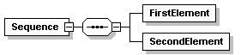  The element Sequence is composed of two (child) elements: FirstElement and SecondElement.
 | This symbol means that an element is made of one and only one of the inner elements. | The element Choice contains as child element either FirstChoice or SecondChoice.
 | This continuous border indicates a mandatory element or attribute within an instance document.  The three lines in the upper left corner indicate that the element has no child element (this notation does not apply to attributes). | The element MandatoryElement must be present in any XML instance document.
 | This dashed border means that the element or attribute is optional within an instance document. | The OptionalElement is optional in any XML instance document.
 | The figures indicate the cardinality. | The element Sequence is made of the following child elements:  - FirstElement: this element must occur at least one time.  - SecondElement: this element is optional and can occur at most five times.
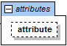 | This symbol indicates an attribute of an element. | 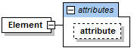
Table 10: XSD Symbols

Annex II: UUID v4

Definition
A version 4 UUID is randomly generated. As in other UUIDs, 4 bits are used to indicate version 4, and 2 or 3 bits to indicate the variant (10₂ or 110₂ for variants 1 and 2 respectively). Thus, for variant 1 (that is, most UUIDs) a random version-4 UUID will have 6 predetermined variant and version bits, leaving 122 bits for the randomly generated part, for a total of 2¹²², or 5.3×1036 (5.3 undecillion) possible version-4 variant-1 UUIDs. There are half as many possible version-4 variant-2 UUIDs (legacy GUIDs) because there is one fewer random bit available, 3 bits being consumed for the variant.

Collision risk
Collision occurs when the same UUID is generated more than once and assigned to different referents. In the case of version-4 UUIDs, collisions can occur even without implementation problems, albeit with a probability so small that it can normally be ignored. This probability can be computed precisely based on analysis of the birthday problem.
For example, the number of random version-4 UUIDs which need to be generated in order to have a 50% probability of at least one collision is 2.71 quintillion, computed as follows:
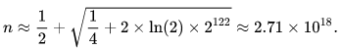
The smallest number of version-4 UUIDs which must be generated for the probability of finding a collision to be p is approximated by the formula
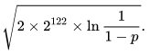
Thus, the probability to find a duplicate within 103 trillion version-4 UUIDs is one in a billion.
In other words, the number of UUIDs generated to have at least 1 collision is 2.71 quintillion. This is equivalent to generating around 1 billion UUIDs per second for about 85 years.
To be noted that, in case of UUID collision, CESOP would consider the second message as a “double submission of the same message” as depicted in section 3.4.16.

https://www.oecd.org/tax/automatic-exchange/common-reporting-standard/schema-and-user-guide/
The following sections describe the validation performed by CESOP. The validation performed by Member States is not part of this document and will be, by definition, different.
In case the TAPAS Party ID cannot be retrieved, BE will be set by default.
Transmitting the positive validation result to the PSP is under the national responsibility.
Transmitting the positive validation result to the PSP is under the national responsibility.
In relation to file compression, it is up to the national implementation whether to accept compressed or uncompressed files from PSPs. However, when sending file to CESOP AS4 Access Point, MSs must ensure that: - the maximal payload size is 1024MB uncompressed; - that payload is then transmitted compressed via AS4 standard.
More information regarding this type of identifier can be found in this page: https://en.wikipedia.org/wiki/Universally_unique_identifier.
This element is part of the DocSpec as defined in other OECD XSDs but has no purpose in the scope of CESOP. If provided, the element will be ignored.
Nevertheless, it is advised to correlate to the last message where the reported payee was successfully validated.
If the NTA can gather the MessageRefId element value from the received message, then it shall be provided. Otherwise, a generic UUID is to be provided: “00000000-0000-4000-8000-000000000000”. The correlation with received message is national domain. It is up to MSs to implement a solution.
For Ping messages, CESOP does not proceed with the validation against the business rules (since those messages are intended for connectivity checking), meaning that this rule will not be triggered for such messages.
Note that for the case of Greece as transmitting country, EL country code is considered equal to GR.
More details can be found in section 3.4.20.
The IBAN length is checked against the country code leading to the account identifier, not the “CountryCode” attribute. For instance, in case the element is reported as follows: “<AccountIdentifier CountryCode="FI" type="IBAN">LT…..</AccountIdentifier>”, the length will be checked against LT, not FI.
This rule is implemented as a record-level error in order to continue the analysis of the submitted message and report other errors that may be present in the file. This rule will produce a full rejection in any case.
In case multiple ‘DateTime’ elements are provided, the validation will proceed according to the following priority: Execution Date, Clearing Date, Authorisation Date, Purchase Date, Other Date, Settlement Date. If one of the provided dates is included in the reported period, the file will be successfully validated.
According to the regulation, the TransactionIdentifier shall be unique in the whole system, not only for a specific period. Nevertheless, this business rule only ensures the uniqueness for each period for performance reasons. Also, note that the same TransactionIdentifier can be used for the transactions that concern refunds, as described in section 3.3.4.
The Validation Result message contains the list of other triggered errors in addition to the error code 50080 (see also the example scenario in section 3.4.17).

